Name: _____________________ UNIT 7 – PLACES TO GO – WEEK 23rd
Class: 5A__

- LOOK AND WRITE
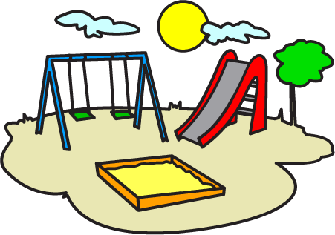
- ……………….. 2.….…………………….. 3.……………………….
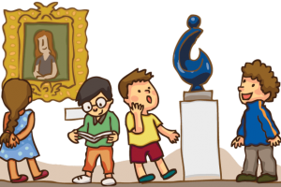
4. ……………….. 5. ….…………………….. 6. ……………………….
II. LOOK AND CIRCLE THE CORRECT WORDS
- We always go /goes to the playground on Saturday. | - She sometimes go/goes to the library.
- My brother doesn’t goes/go to the shopping mall. | - Anna never rides/ride her bike at the weekend.
- My sister always take/takes photos. | - The children always go/goes to bed at nine o’clock.
- My friends always fly/flies the kites on Sundays. | - I sometimes watch/watches TV.
- My father always go/goes to the café every morning. | - My family always go/goes to the movie theater on Saturdays.
- What do you always eat/eats for breakfast ? | - Jane sometimes go/goes to school by bus.
- Toby always goes /go to the café before work. | - Peter never go/goes to the library.
- We never eats/eat ice cream after dinner. | - We sometimes go/goes to the swimming pool on Sundays.

III. WRITE SENTENCES. PUT THE ADVERBS IN THE CORRECT POSITION.
1. We go to the cinema. (sometimes)
We sometimes go to the cinema.
2. Anna gets up early every morning.(always)
………………………………………………………………………….
3. Do you go to the movie theatre ? (never)
………………………………………………………………………….
4. Does Laura have breakfast with her family? (always)
………………………………………………………………………….
5. David doesn't study new words before his tests (never)
………………………………………………………………………….
6. They read books in the library on Sunday. (always)
………………………………………………………………………….
7. We go to the swimming pool on Sunday. (sometimes)
………………………………………………………………………….
8. Ann surfs the net in the evening. (always)
………………………………………………………………………….
9. Do they go swimming on Sunday ?. (often)
………………………………………………………………………….
10. He listens to music in his free time. (often)
…………………………………………………………………………
IV. Fill in : in , at , on
On Monday | …………….. 6:15
…………….. the morning. | …………….. the afternoon
…………….. 8:30 | …………….. Thursday
…………….. the evening | …………….. night
…………….. Friday | …………….. 9:45
…………. the summer | ………….. Monday morning
…………. the weekend | ……………. the winter

V. PUT THE WORDS IN THE CORRECT ORDER TO MAKE SENTENCES
1. sometimes /reads /He /in /the /afternoon / . /books/
………………………………………………………………………………….
2. play /They /always /tennis / on / Saturday/ ./
………………………………………………………………………………….
3. swims /always /My /sister /in /summer / ./ the
………………………………………………………………………………….
4. never /goes /She /shopping /Monday / ./ on/
………………………………………………………………………………….
5. drives /sometimes /car /He /his /work / ./to /
………………………………………………………………………………….

