Vinh Hoa A primary school
Class 4A……
Name:……………………
Mark | Teacher’s comment

I. Write the words.
Unit 8 / grade 4
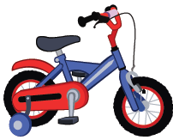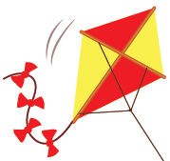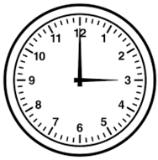

……………. ……………. ……………. ……………. …………….

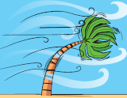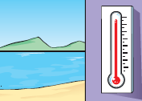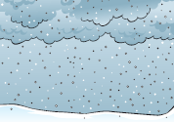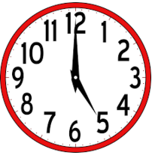

……………. ……………. ……………. ……………. …………….

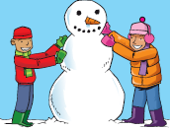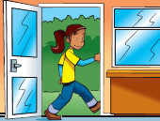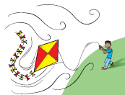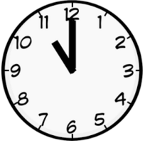

……………. ……………. ……………. ……………. …………….

II. Arrange the words.
1. playtime / it’s / sunny /it’s /outside, …………………………………………………………
2. raining/ it’s / your / on/ raincoat,/put, ………………………………………………………
3. sun / hat/ don’t/ put/ your /on …………………………………………………………
4. the / door/ please / close …………………………………………………………
5. don’t / our / have / we / coats, ………………………………………………………….
6.It’s / What/ weather /the / like?/ Monday……………………………………………………...

III. Read and write the number under the correct picture.

………………. ….. ………… ………………….. ……………

1. Fly a kite.
2. Don’t put on your coat.
3. Put on sun screen.
4. Make a snowman.
5. Take your umbrella.
6. Put on your coat.
7. It’s snowing.

……………… ……………. ……………….

Unit 7 & Unit 8
I. Odd one out.
1. a. store b. station c. fire fighter d. zoo
2. a. police officer b. airport c. teacher d. pilot
3. a. work b. fly c. go d. in
4. a. sun b. raining c. windy d. hot
5. a. big b. weather c. wet d. cold
6. a. windy b. sun hat c. coat d. umbrella

II. Choose the words.
1. It’s one o’clock ……..the afternoon. a. at b. on c. in
2. I wear ……… to go outside. a. big a hat b. a big hat c. a hat big
3. It’s very……..outside now. a. windy b. wind c. winding
4. …… your sister work in a hospital? a. Is b. Do c. Does
5. My grandma……..in a zoo. a. makes b. works c. puts
6. ………the weather like today? a. What’s b. What c. What does
7. It’s raining. …….go home. a. Let b. Lets c. Let’s
8. The parrot is ………. a. blue and green b. wet and green c. sunny and hot
9. The lions ………meat. a. go b. eat c. work
10. Does he work in a store? - ……. a. Yes, he is. b. Yes, there is. c. Yes, he does.

III. Complete.
My mother is ……….. 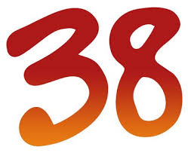 years old. She works ………. a ………… . My father is a ………………… . He …………. in a …………..  . I and my brother are ……………. 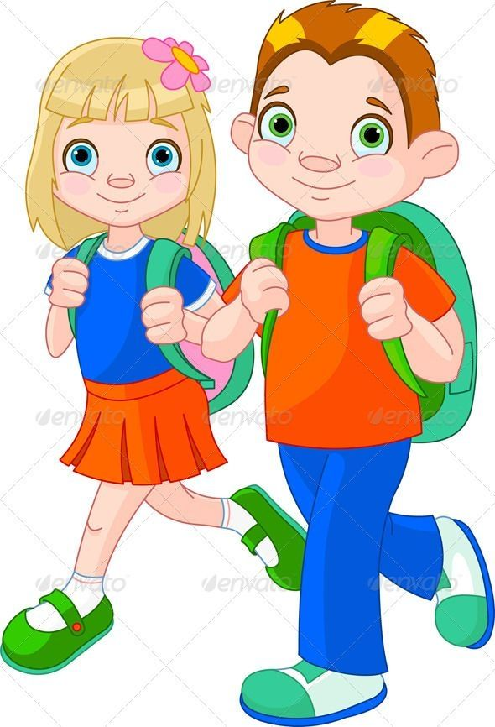. We like to go to the…………………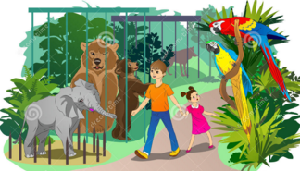. We like summer, too. When it’s ………….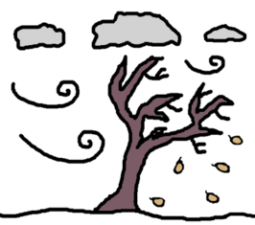, we can …………………….. 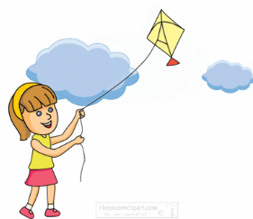.
When it’s ……………… , we can …………………………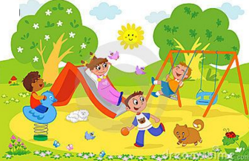

IV. Read and answer the question.
How to wrap a gift.
This is a present for my friend, Long. It’s a box of candy.
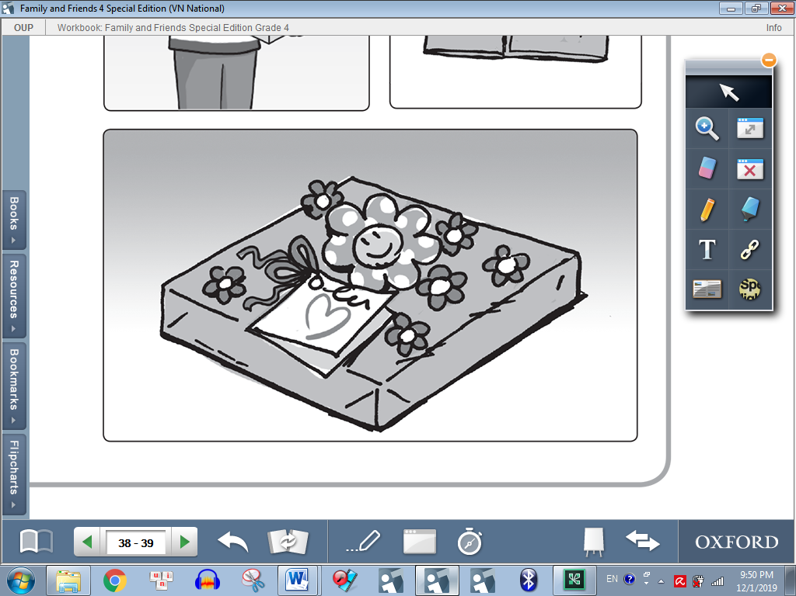
1 Get paper. Long’s favorite color is blue, so this is a blue paper.
2 Put the gift on the paper.
3 Fold the paper.
4 Tape the paper.
5 Make triangles with the paper. Tape the triangle.
6 Tape the stickers on the gift. Long likes stickers.
7 Write in a card. My card says, “To Long, you are a good friend. From Minh.”

1 What is the gift? 2 What is Long’s favorite color?
A a box of chocolate A red
B a box of candy B brown
C a box of nuts C blue
3 What does Long like? 4 What shape do they make?
A flowers A triangle
B stickers B square
C dolls C circle
5 Who is the gift from?
A Long
B Lam
C Minh

