Vinh Hoa A primary school Review – Grade 4
Name:………………………
Class 4A...
Mark | Teacher’s comment

I. Look at the picture and do the task.
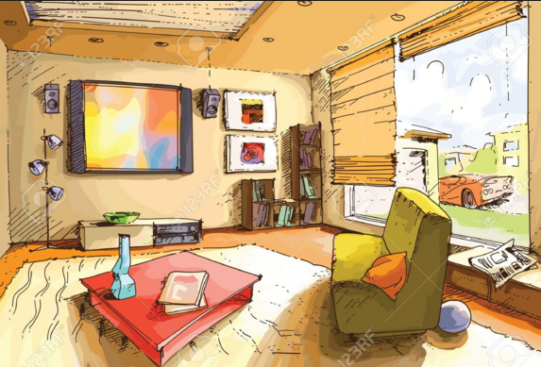
True (T) or False (F)
1. It is a living room. ……….
2. There is a T.V. on the wall. ………
3. The computer is in the room. ………
4. The toy box is near the window. …….
Answer.
1. Is there a sofa in the room?
2. How many books are there on the table?
3. Where is the ball?
4. How many pictures are there on the wall?
5. Is there a shelf in the room?
6. Where is the pillow?
II. Write the words.
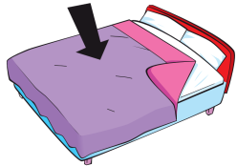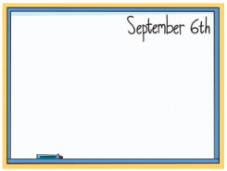
________ _________ _ _________

___________ __________ _______________
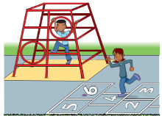 50
_____________ __________ _______________

III. Write sentences with: like/ don’t like / likes / doesn’t like
1. Rosy 2. Tim
……………………………… ………..……….…………………
3. Mom 4. Billy
………………………………………… ……………………………………
5. I 6. I
……………………………… ………..……….…………………
7. She 8. He
………………………………………… ……………………………………

IV.Look at the table and answer.

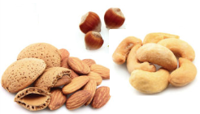
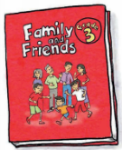
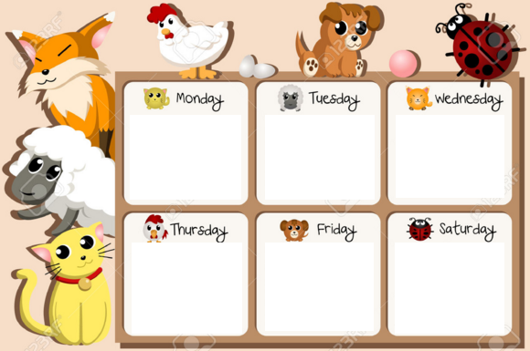
1. What do we have on Monday? …………………………………………
2. Do we have English on Thursday? …………………………………….
3. When do we have music? ……………………………………………..
4. Do we have art on Wednesday? ……………………………………….
5. What do we have on Friday? …………………………………………..
6. When do we have English? ……………………………………………
7. What do we do on Saturday? ………………………………………….
8. Do we have music on Friday?..................................................................

V. Make sentences.
1. Andy 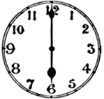 ……………………………………………………………
2. Dad 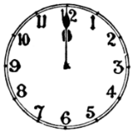 …………………………………………………………………..
3. Hoa …………………………………………………………………….
4. Nam …………………………………………………………………..
5. I  

