Vinh Hoa A primary school
Name: ………..
Class 2A……
Review 1-6
Unit 1
1 - 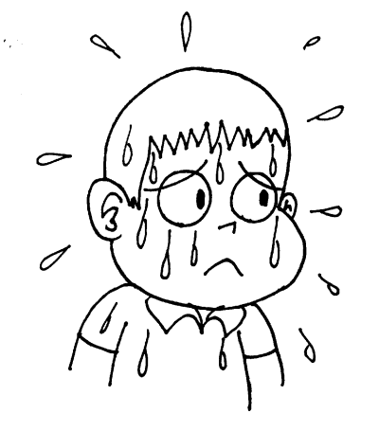
2 - 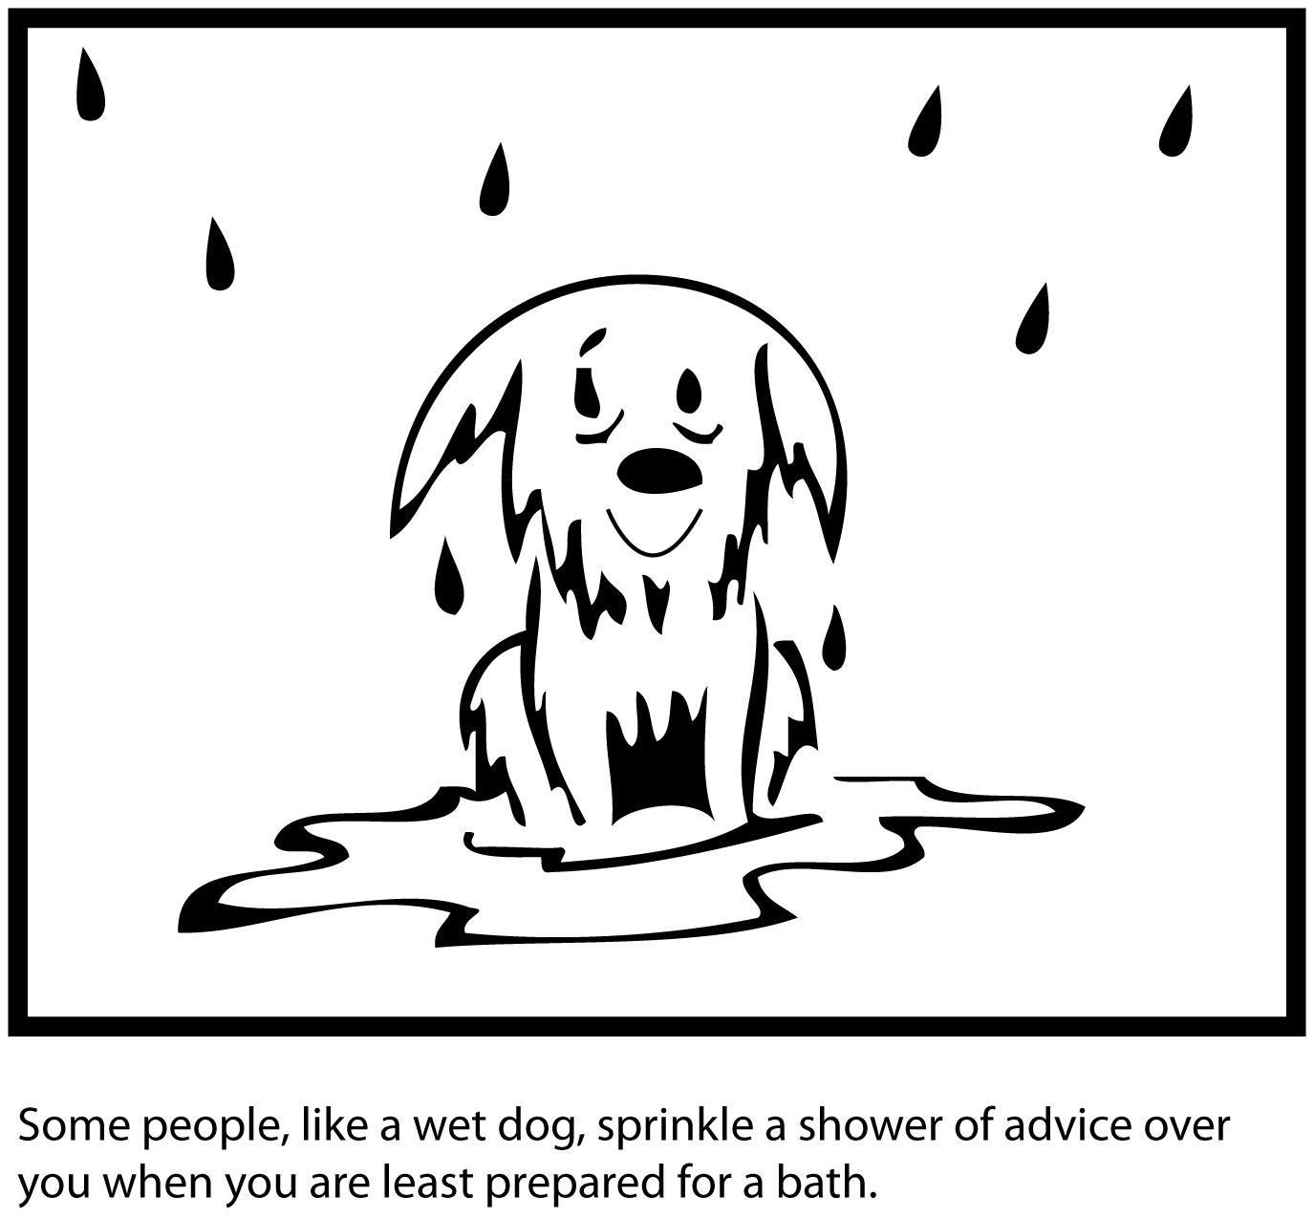
3 - 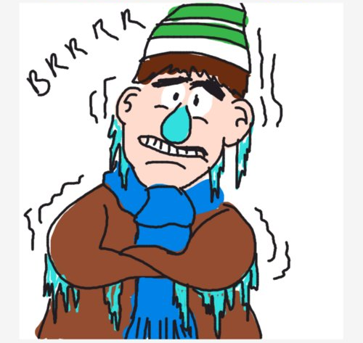

Task 1 Look and write
1.It’s …………………………….
I’m……………………..……...
2.It’s …………………………….
I’m…………………..………...
3.It’s …………………………….
I’m…………………..………...
Task 2 . Unscramble (xếp lại cho đúng)
1. sunny! /It’s / hot/am /I =>…………………………………………
2. It’s/ I/ raining/ am/ wet. =>………………………………………….
3. snowing/ cold!/ It’s / am/ I =>…………………………………………
Task 3: Fill the blank
1. Hu…….. up! It’s ra……………….
2. It’s s…………I’m h………………
3. It’s sn……………I’m c…………
4.. It’s ra………I’m w……………..

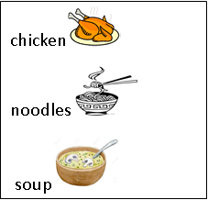
Unit 2
Task 1: Look and write
chicken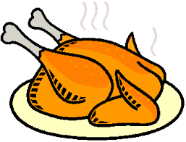
noodles
soup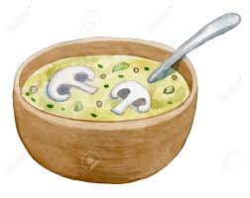

- I’m hungry
Have some …………..
Mmm.It’s good
- I’m………………….
Have ……………….
Mmm. It’s………….
- I’m………………….
Have ……………….
Mmm. It’s………….

Task 2: Fill the blank
1. I’m hu…..ry. Have some ch………...
2.I’m hu………ry. Have some s………
3. I’m hu……ry. Have some no……….
4. Mmm. It’s g………
Unit 3
Task 1:Read and match
a
b 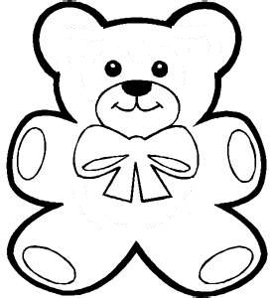
c
d 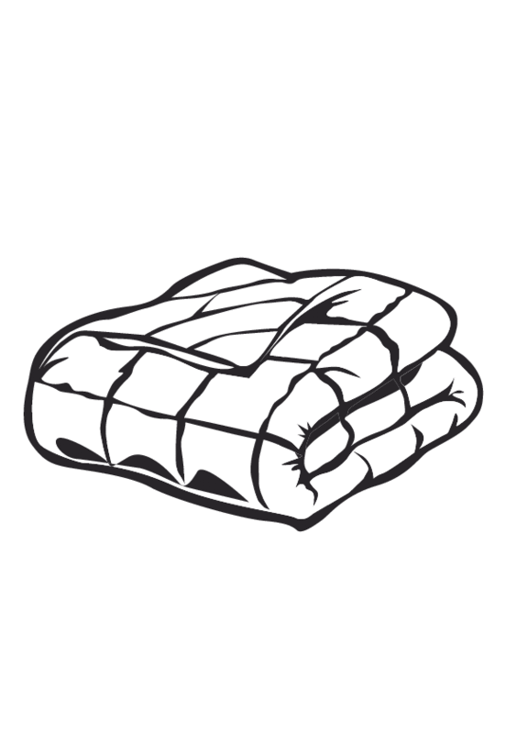

1.That’s my pillow.
2.That’s my blanket.
3.That’s my bear.
4. That’s my bed.
Answer
1…….
2…….
3……..
4………
Task 2: Fill the blank.
- That’s my p…………..No, It’s my p……………
- That’s my bl………….No, It’s my bl……………..
- That’s my be…………No, It’s my be…………….
- Be q…………!

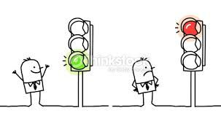
Unit 4
Task 1 Look and write
……. light. Stop!
…….. light. Go!

Task 2 Fill the blank.
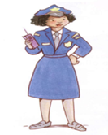.She’s a………. 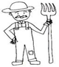…….’s a……….
He’s a…………… …….’s a………..
……..’s a……….. ……….’s a……….
Task 3. Unscramble
- Go!/ green / light =>…………………………………
- light/Red /stop! =>…………………………………
- is / She/ a/ doctor. =>………………………………….
- police officer/ is/ He / a =>………………………………….
- She/ a / farmer./ ‘s =>………………………………….
Unit 5
Task 1 Fill the blank.
1. I want …………………

2. I want ………………..

3. I want ………………..

4. I want ………………….

5. I ………………………...

Task 2.Find the odd one out.
1. A candy B chips C milk D ice-cream
2.A candy B mommy C daddy D sister
3. A How B farmer C teacher D want
4. A sunny B weather C snowing D raining
5. pillow B bear C blanket D bread
Task 3 Unscramble
1. want/ chips / I/ chicken/ and ……………………………………..
2. No, / not / Sue/ today. ………………………………………
3. I/ ice-cream / want / ……………………………………….
4. I/ candy./ want/ not/ No, / today./ benny………………………………………..
5.That’s / bedroom./ her …………………………………………

Unit 6
Task 1: Look and write.
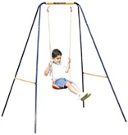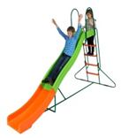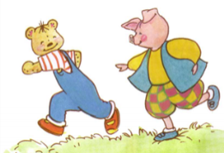
Play …….. me Play ……………….. Play………………..
Ok. Let’s ………. Ok. Let’s………….. Ok. Let’s………….
Task 2 Circle the best answer.
1. Play ……. me!
A to B with C OK
2. Ok! ……………. slide !
A Let’s B she C Lets
3…….. with me! Ok! Let’s …………….
A Play ….. OK
B Me …… run
C Play…… swing!
4. She is a …………
A. farmer.
B faremer.
C sunny.
5. I want ……….
A sunny
B ice-cream
C doctor.

