Vinh Hoa A Primary School Test
Class :1A..........................
Name : ..............................
Marks | Remarks of teacher

I. Which is different? Circle : ( Cái nào khác? Khoanh tròn )

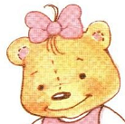
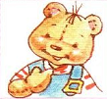

II. Write (Viết)

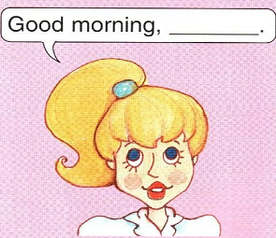
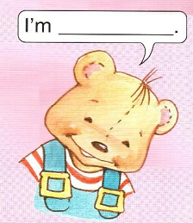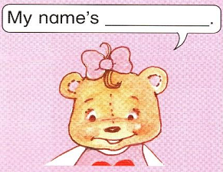

III. Unscramble (xếp lại cho đúng)

1. Sue. 'm I ………….
2. Sue. Hello, …………………………………………….
3. Name Benny My 's …………………………………………….
4. Miss Dolly morning Good ………….
5. My Sue name is ………………………………...................
6. boy/ I / am/ a …………………………………………….
7. a / I / am/ teacher ……………………………………………

IV.Look and fill the blank

1. I am _________

2. I’m ____________

3. I am _____________

V. Match
1. My name’s Sue. A. I’m fine!
2. How are you? B.Good morning, Nam
3. I’m Sue C.Hello, Sue
4.My name’s Nam. D. Good morning, Sue.
1……. 2…….. 3…….. 4……….

