ĐỀ ÔN TẬP TỪ 23/3 _ 26/3/2020
VINH HOA A PRIMARY SCHOOL.
NAME: _____________________________.
CLASS: 3A__
REVIEW FOR GRADE 3
I.Write the words:
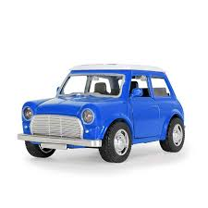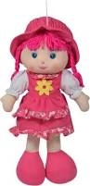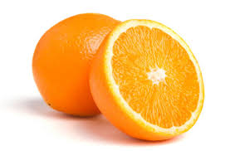
____________ _______________ ______________ ______________
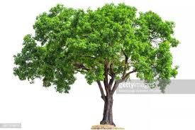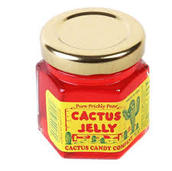
______________ ______________ _____________ _____________
II.Write the numbers:
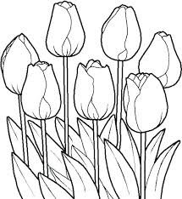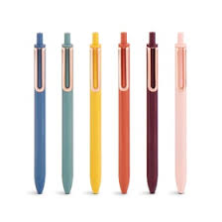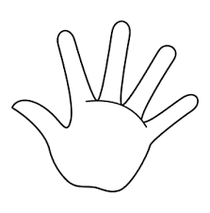
______________ ______________ _____________ ______________
III.Look and read. Put a check (√) or a cross (×) in the box:
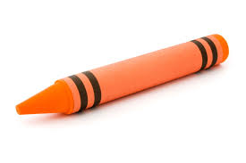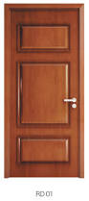

He’s a pilot. This is a crayon. Open the door. She is my grandma.
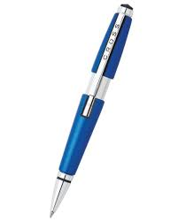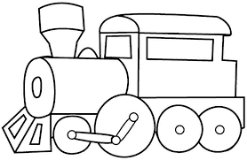

This is my book. It’s a car. He’s a teacher. She’s a doctor.
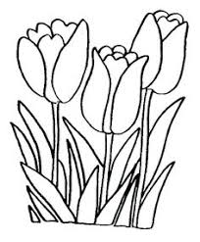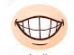

This is my hand. It’s in the box. There are three flowers. This is my teeth.
IV. Write the sentences with a capital letter and the start of the name:
1.these are my ears _____________________________
2.this is harry _____________________________
3.he is a firefighter _____________________________
4.hoa and nga are students _____________________________
5.this is my friend, Billy _____________________________
6.my name is Lan _____________________________
V.Write the words in the box:
family | jobs | numbers | toys | colors | Part of the body
VI.Look at the picture. Fill in the correct circle.
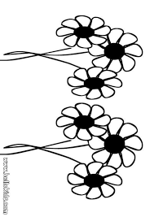
A. This is my friend. ⃝
B. This is my class. ⃝
C. This is my family. ⃝
A. Three. ⃝
B. Six. ⃝
C. Ten. ⃝
A. ice cream. ⃝
B. apple. ⃝
C. orange. ⃝
A. Play with a frisbee. ⃝
B. Play with a ball. ⃝
C. Play with a yo-yo. ⃝
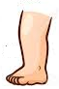
A. This is my nose. ⃝
B. This is my hand. ⃝
C. This is my leg. ⃝
A. They are students. ⃝
B. They are doctors. ⃝
C. They are pilots. ⃝

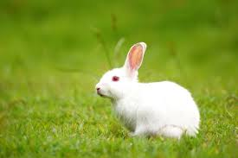
A. This is my eye. ⃝
B. This is my finger. ⃝
C. This is my arm. ⃝
A. bird. ⃝
B. rabbit. ⃝
C. zebra. ⃝
VII. Look at the pictures and write:
2.This is my _____________.
1.It is an ____________.

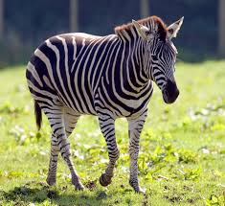
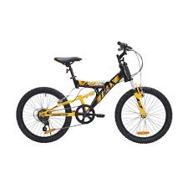
3.Look at the ____________.
4.This is my _________.

6.The tiger has an ______________.
5.Where’s the __________.

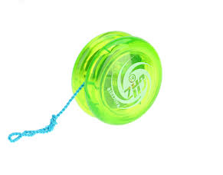
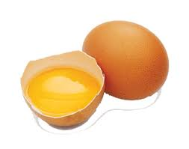
8.Play with a ____________. _________________.
7. I want an _______.

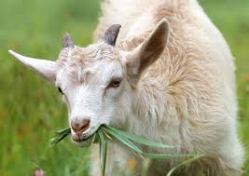
10.I have a _________.
9.This is my ____________.

VIII.Look at the pictures and match. Then write:
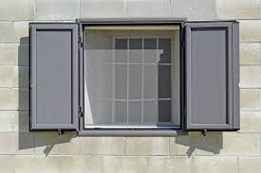 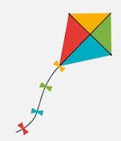1.________________ 2. _____________
S

W

B

H

T

V

P

K
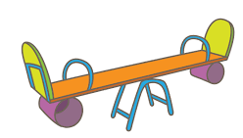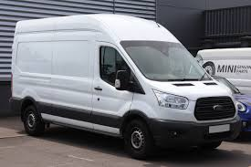
3._____________ 4._____________________ 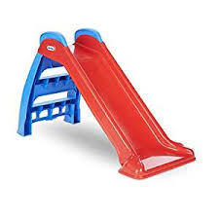 5._______________ 6._______________
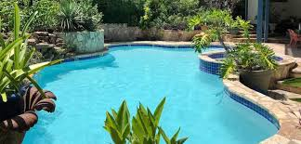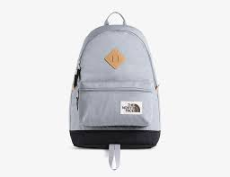
7._____________ 8. _______________
9._____________ 10._____________
IX.Read. Write words from the box.
pool slide kite chair

Hoa’s brother wants his (1) _______________. Mother looks in the (2) ______________.Grandpa looks on the (3) ________________.They can’t find it. Hoa looks under the (4) ______________. There it is! They are happy!
X.Look at the picture and write:
