Name: _____________________ REVIEW GRADE 5

1. READ AND WRITE THE NEXT MONTHS
January
June
September

What month is it ? It’s _____________ What month is it ? It’s _____________
What month is it ? It’s _____________ What month is it ? It’s _____________
What month is it ? It’s _____________ What month is it ? It’s _____________
What month is it ? It’s _____________ What month is it ? It’s _____________
What month is it ? It’s _____________ What month is it ? It’s _____________
2. FILL IN THE BLANKS WITH AM, IS, ARE, WAS, WERE
a. It ______sunny yesterday, but now it _______rainy.
b. They ________at school this morning. Now they _______at the pool.
c. I _____small when I was 5. Now I ______big.
d. The children _________happy now.
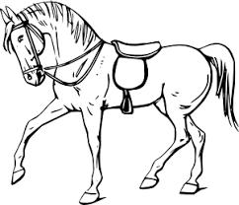
3. COMPLETE THE SENTENCES USING COMPARATIVE ADJECTIVES

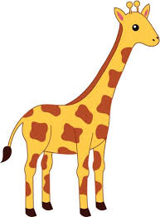
The horse is _____________________the cow. ( fast)
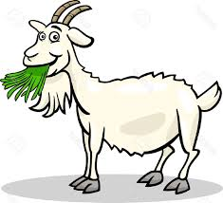
The giraffe is _____________________the goat. ( tall)
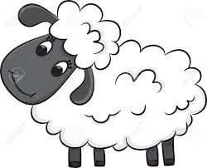
The elephant is _____________________the sheep. (big)
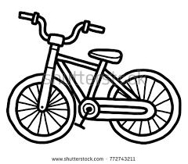
The bike is _____________________the car. (small)

4. WRITE THE NUMBERS IN WORDS
50
45
36
30

100
89
75
57
5. LOOK AND WRITE
Jeong/8/Korea  My name’s Jeong. I’m 8. I’m from korea. | - Mary/10/Australia  My ____________________  _______________________  _______________________ | 2.Jessica/7/Brazil  Her ___________________  _______________________  _______________________
Ben/12/ the U.S.A  His name is Ben.  He’s 12. He’s from the USA. | 3.Andros/15/Mexico  His_____________________  ________________________ | 4.Anita /10/Thailand  My____________________  _______________________

6. READ AND ANSWER
Name: Nguyen Thi Lan  Hometown: Ho Chi Minh City, Viet Nam  School: Nguyen Hue Primary School  Class: 4a5 | Name: John  Hometown: London, England  School: International Primary School  Class: 4a1

- What is the girl’s name? __________________________________
- Where is she from? _______________________________________
- What is her school’s name? _______________________________
- What nationality is she? __________________________________
- What is the boy’s name? __________________________________
- Where is he from? _______________________________________
- What is the name of his school? ____________________________
8. What nationality is he? _______________________________
7. WRITE QUESTIONS AND ANSWERS.
 | is /Where/Anna/ from ?  …………………………………… | from/She/is/Thailand./  ……………………………………
 | is/Where/John/ from ?  …………………………………… | from/He/is/England./  ……………………………………
 | they/Where/are/ from ?  …………………………………… | They/are/Brazil./from/  ……………………………………
 | is/Where/Lucas/ from ?  …………………………………… | from/He/is/Mexico./  ……………………………………
 | /Where/Jeong /from ?/is  …………………………………… | from/She/is/Korea./  ……………………………………
8. MATCHING
- What’s your name ? | - I’m nine years old.
- How old are you ? | - My name is Lisa.
- Where are you from ? | - My favorite season is fall.
- What’s your favorite season ? | - I’m Korean.
- When is your birthday ? | - I’m from the U.S.A
- What nationality are you ? | - It's on the first of January.
- Do you like summer ? | - There are four seasons.
- How many seasons are there in a year ? | - Yes, I do.
- Where is she from ? | - No, they aren’t
- Are they from England ? | 10.She is from Brazil.
- Is she from Viet Nam ? | 11.Yes, she is
a____ b_____ c_____ d_____ e_____ f_____ g_____
h_____ i______ j______ k_____
9. LOOK AND WRITE

10. READ THE WRITE T (TRUE) OR F( FALSE)
Hello, my name’s Minh. I live in Binh Duong. I’m 11 years old. I like summer and spring. In the summer, it rains a lot but it’s often hot so I can go swimming. I like to play badminton with my friends every day because I don’t have to go to school.
In spring, there are many beautiful flowers. The weather is fine. I often go for picnic and play outside with my cousins.

1. Her name’s Minh. T 5. In spring, the tree lose their leaves
2. Minh is ten. 6. Minh goes to school every day in summer.
3. It doesn’t rain in summer. 7. In spring, the weather is nice.
4. It’s hot in summer. 8. She loves summer and spring.
11. COMPLETE THE SENTENCES USING: “IN; ON; AT”
  - My birthday is ……………………… March.

  - We go to the café ……………………… Saturdays.

  - There’s a party ………….. 8 o’clock tonight. Would you like to come?

  - Mai is going to Hanoi ………………………. Sunday.

  - The class starts ……………………… 7.30 every morning.
12 . COMPLETE THE SENTENCES WITH THE WORDS IN THE BOX.

cooks; holiday; mall; Sundays; living; tomato; tennis

- I sometimes help my dad to tidy up the (0)…living….room.
- He sometimes plays (1) …………………… with his friend.
- We never go to school on (2) …………………………..…….
- My mum always (3) ………….....……… cakes on special days.
- We sometimes go on (4) ……………………..… to the mountains.
- We always have cheese and (5) ……………………. on pizza.
- I sometimes go to the shopping (6) ……………… with my cousins.
13. WRITE “WAS/ WERE” TO COMPLETE THE SENTENCES.
  - I ………………………… at school yesterday.
  - My mum ………………………… ill last night.
  - My cousins ………………………. in the garden 1 hour ago.
  - Peter…………………………… in the kitchen this morning.
  - My dad ………………………… at work yesterday.
  - The children ………………………. Happy last week.
- CORRECT THE MISTAKES OF THE SENTENCES.
- How many boats do she have?
…………………………………………………………………
  - What color are her mother hair?

…………………………………………………………………
  - My babies are playing to paper ships?

…………………………………………………………………
  - Do your sisters like swimming? – Yes, they are.

…………………………………………………………………
  - The weather is snowy on the winter in Sapa.

…………………………………………………………………
  - Do your sister and you skipping in the garden?

…………………………………………………………………
15. WRITE THE SENTENCES. PUT THE ADVERB IN THE CORRECT POSITION. FOLLOW THE MODEL.
0. We go to the cinema. (sometimes)
➔ We sometimes go to the cinema.
- She doesn’t go to the swimming pool. (usually)

…………………………………………………………………….
- Helen and Peter go to the theatre. (never)

…………………………………………………………………….
- I buy the ticket. (always)

…………………………………………………………………….
- He goes to the café. (never)

…………………………………………………………………….
5. You’re late (always)

…………………………………………………………………….

16. COMPLETE THE SENTENCES USING: “THERE WAS/ THERE WERE”

  - 3 parks/ in 1958

➔ There were 3 parks in 1958.
  - A bus station/ in 2008

……………………………………………………………………..
  - 10 cinemas/ in 1999

……………………………………………………………………..
  - Some bus stations / in 2005

……………………………………………………………………..
  - one train station/ in 2001

……………………………………………………………………..
  - Lots of hotels/ in 2010

……………………………………………………………………..
17. MAKE SENTENCES NEGATIVE.

- There was a cinema in 2008.

……………………………………………………………………..
- There were some trams in 2002.

……………………………………………………………………..
- There were some bus stations in 1989.

……………………………………………………………………..
- There were lots of parks in 2000.

……………………………………………………………………..
- There was a national stadium in 1999.

……………………………………………………………………..
18. REORDER THE WORDS TO CORRECT THE SENTENCES.
1. Grandma/ short hair/ had/ when/ a girl/ she was.

……………………………………………………………………..
- Is/ grandma/ now/ sixty.

…………………………………………………………………….
- Is/ very generous/ Grandma.

……………………………………………………………………..
- Is/ Grandma/ sometimes/ miserable.

……………………………………………………………………..
- Grandma/ grey hair/ now/ has.

.........................................................................................................
19 . LEAVE ONE UNNECESSARY LETTER IN THESE WORDS TO MAKE THEM CORRECT.
1. | TREAM | ………………………………………...
2. | V R E I R | …………………………………………
- HELICOPATER …………………………………………

- MOTOREBIKE …………………………………………

5. | MUASEUM | …………………………………………
6. | BETSWEEN | …………………………………………
7. | INSAIDE | ………………………………………….
8. | THAROUGH | ………………………………………….
20. COMPLETE THE WORDS WITH: “OW AND OU”
1. | D_______n | _________t
2. | Br_______n | fl________er
3. | Sh_______t | cl________n
4. | M_______se | tr________sers
5. | C________ | h________se
21. CHOOSE THE BEST ANSWERS.
1. | Ann and her brother …….......... |  |  | …. at home
 | A. is |  | B. do |  | C. are | D. does
2. | How many… | ..........… has she got?
 | A. sheep |  | B. cat |  | C. mouse | D. toy
3. | My father works on the farm. He is a … |  |  |  | ........……
 | A. worker |  | B. doctor |  | C. farmer | D. teacher
4. | I’m …............ | ….. fishing with my dad.
 | A. go |  | B. to go |  | C. going | D. go to
5. | My friends and I … |  | ..........…. skipping in garden.
 | A. is |  | B. am |  | C. are | D. do
6. | Why does s Alex go to the ……...?- Because he wants to see a movie.
 | A. park |  | B. bookshop |  | C. city | D. cinema
7. | The Browns never ……............ |  |  | … dinner together.
 | A. has |  | B. having |  | C. had | D. have
8. | The book is open in front …............. |  |  | ….. her on the desk.
 | A. of |  | B. to |  | C. with | D. by
22. READ AND ANWER THE QUESTIONS
Hi. My name’s Chi. I’m from Binh Duong province. I’m ten years old and I’m in grade 5 at VHA primary school. I have to learn many subjects at school and I like English the most. My birthday is in February. My favorite season is autumn because the weather is so cool. I like playing soccer and reading comics when I have free time. Sometimes, I also go fishing with my dad at the weekend. I don’t like playing game because I think it is not exciting.
- What’s her name ? => ………………………………………….
- Is she from HCM city ? => ………………………………………….
- How old is she ? => ………………………………………….
- What’s her favorite season ?=> ………………………………………….
- When’s her birthday ? => ………………………………………….
- Does she like reading comics ?=> ………………………………………….
- Does she like English ? => ………………………………………….
- Which grade is she in ? => ………………………………………….
23. Reorder the words to make sentences
1. they / Are / cousins / our / ? => ……………………………………………..
2. The / were / children / sad => ……………………………………………..
3. elephant / The / bigger / is / than / monkey / the
=> …………………………………………………………………………….
4. boy / The / thirsty / was => …………………………………………….

24. LOOK AT THE TABLE. WRITE QUESTIONS TO ASK FOR PERMISSION AND MAKE REQUESTS
Permission | Requests
1. turn up the music | 2. turn off the DVD player
3. go to the cinema | 4. give me the newspaper
5. play with my friends | 6. go to the shop for me
7. have a new coat | 8. help me in the kitchen

- ________________________________________________________
- ________________________________________________________
- ________________________________________________________
- ________________________________________________________
- ________________________________________________________
- ________________________________________________________
- ________________________________________________________
- ________________________________________________
25. WRITE : HIS _ HER _ OUR _ YOUR _ THEIR.
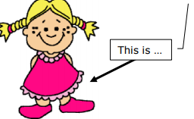 | • ______ name is Lucy.  • ______ eyes are brown.  • She has long hair.  • She has a brother, ______ name is Leo.  • ______ (= Lucy’s) dress is red.
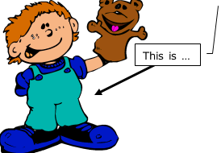 | • ______ name is Paul.  • ______ shoes are big and blue.  • ______ puppet is a bear  • Paul has two sisters, ______ names are Patty and Pippa.
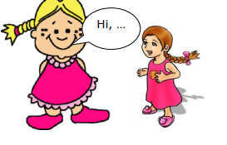 | • "Hi, ______ name's Ella.  • This is ______ friend, ______ name's Katie.  • Katie and I love many colors, but ______ favorite is pink.  • Katie is pretty, ______ hair is brown and ______ eyes are green."
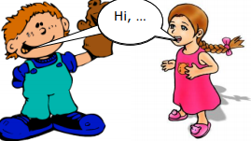 | - "Hi, ______ names are Lisa and Joe.  • We have two cats, ______ names are Mr Little and Miss Milk. We go to school, ______ teacher is Ms .Miller."

26. LOOK AT WRITE

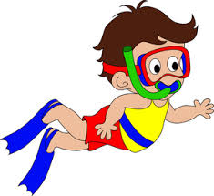

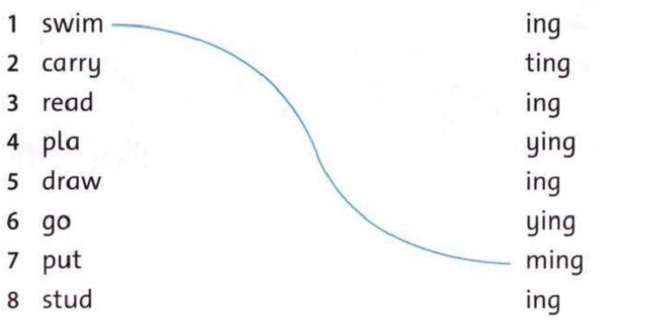
27. MATCH 1-8 WITH THE CORRECT ENDING TO MAKE –ING WORDS
swimming

28. LOOK AND ANSWER THE QUESTIONS
What are they doing ?  ___________________________ | What are they doing ?  ____________________________ | What is she doing ?  ____________________________
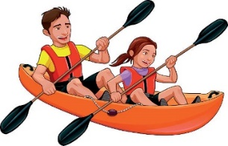 |  | 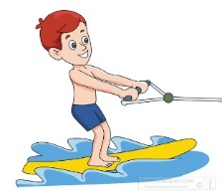
What are they doing ?  ___________________________ | What is she doing ?  ___________________________ | What is he doing ?  ___________________________
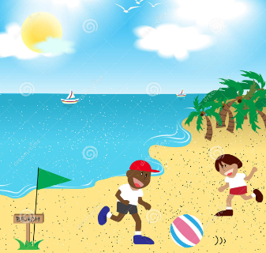 | 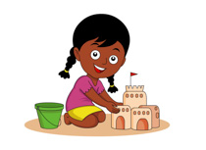
What are they doing ?  ____________________________ | What is she doing ?  ____________________________ | What is he doing ?  ___________________________

29. Read the paragraph about vung tau and then do exercises
Welcome to Vung Tau!
Vung Tau is a beautiful city. The beach is long with white sand.
The water is not polluted. It’s clean. You can go there for your summer vacation. You can swim or build sand castle there.
There are a lot of seafood stores, you can enjoy seafood. It’s very delicious.
The beach is safe for you to swim and you can play volleyball or football on the beach. It’s interesting.
Come to Vung Tau. It’s great!
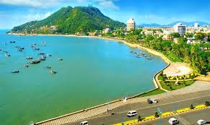

- True or False (T or F)
- There is a short beach with white sand in Vung Tau. _______
- The water is not clean.________
- You can’t swim in the sea because it’s dangerous._______
- You can do many activitivies on the beach.________
- Read and choose
- The beach is long/ short and white.
- Seafood is bad/ good.
- You can build house/ sand castle on the beach.
- We can play soccer on the beach. It’s boring/ interesting.

30. ANSWER THE QUESTION ABOUT YOU.
- What do you like doing at the beach? _____________________________________
- Do you like taking photo? _______________________________________________
- Do you like sailing? ________________________________________________
- What do you like doing in your free time ?
_______________________________________________
- Where are you from ?
_______________________________________________
- Are you a teacher of English ?
_______________________________________________
- What animals do you like ?
_______________________________________________
- What colors do you like ?
_______________________________________________
- When is your birthday ?
_______________________________________________
- What is your favourite season ?
_______________________________________________
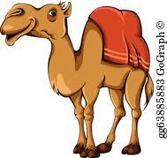
31. REORDER LETTERS TO MAKE WORDS.
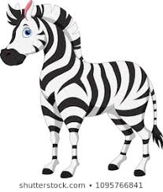

roccodlie zbear cmale
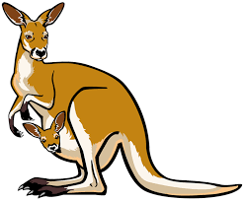

enpuing knagraoo liarzd

32. WRITE QUESTIONS, USING THE PRESENT CONTINUOUS.
Ex: he/ play/ chess Is he playing chess?
- Jane / do/ her homework?
_________________________________
- We / have/ dinner / now?
_________________________________
- You and Tom / play / computer game?
_________________________________
- the monkey / eat / a banana?
_________________________________
- the baby / drink/ milk?
_________________________________
33. LOOK AND WRITE
Yes, it is  No , it isn’t. | Yes, they are.  No, they aren’t.

Is the frog playing the guitar ?  ________________________ | Is the parrot reading a book ?  ________________________ | Are the birds singing?  __________________
 | 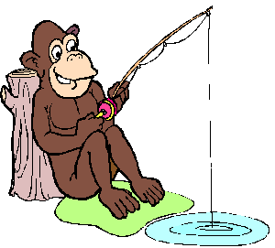
Is the rat sleeping ?  ______________________ | Is the monkey fishing?  ____________________ | Is the owl writing?  ____________________
 | 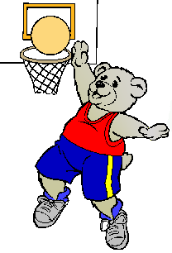
Are the cats fighting?  ________________________ | Is the bear playing volleyball?  _________________________ | Is the penguin surfing ?  ______________________
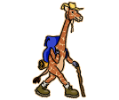

Is the giraffe walking ?  ____________________ | Is the dog running?  ___________________ | Is the squirrel kayaking ?  ____________________

34. WRITE THE QUESTIONS FOR THESE ANSWERS
__________________________________?
No, the monkey isn’t flying. It’s climbing.
Is the lion sleeping?
Yes, the lion’s sleeping.

__________________________________?
Yes, the parrots are flying.
_______________________________________?
No, the zebra isn’t eating. It’s running.
_______________________________________?
No, the kangaroos aren’t sleeping. They are eating. climbing.

35. CHECK THE MISTAKE AND CORRECT IT.
1. The cats is running.  The cat is running. | 2. The lizard are sleeping.  __________________________
3. Tony like playing fooball.  _________________________ | 4. There is tall trees and pretty flowers.  _______________________________
5. He are kicking the ball.  ____________________________ | 6. I am run and catching the ball.  ________________________________
7. My friend are playing hike and seek.  ____________________________________ | 8. My mom and my dad is walking in the park now.  _____________________________
9. We is going to the moutain.  __________________________________ | 10. They are going at school.  _____________________________

