**Name: _________________ REVIEW – GRADE 5**

**I. Read and match.**

|  |  |  |
| --- | --- | --- |
| *0.What are you doing?* | A. She’s playing the guitar. | ***0-C*** |
| 1. Where are you from? | B. Yes, they are. | **1-** |
| 2. I like fishing. | *C. I’m singing.* | **2-** |
| 3. Is the tiger angry? | D. My favorite season is summer. | **3-** |
| 4. What’s your favorite season? | E. No, it isn’t. It’s happy. | **4-** |
| 5. Do you like reading comics? | F. I like surfing. | **5-** |
| 6. What is she doing? | G. Yes, I do. | **6-** |
| 7. What do you like doing at the beach? | H. I like fishing, too. | **7-** |
| 8. Are the parrots flying? | I. I’m from Korea. | **8-** |

**II. Read the passage and do exercises**

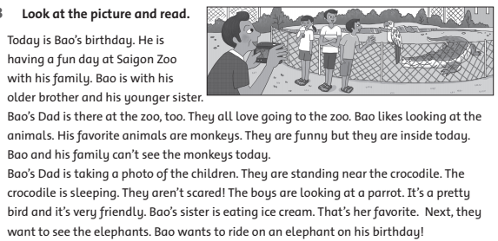

1. **Answer the questions**
2. What is Bao’s dad doing? __________________________________
3. Is the crocodile sleeping? ___________________________________
4. What does Bao like doing? ___________________________________
5. What is Bao’s sister doing? ___________________________________
6. Is it Bao’s birthday today? ___________________________________
7. **True (T)/ False (F) statements**
8. *They are at the zoo.* *T*
9. Today is Bao’s dad birthday. __________
10. Bao doesn’t like looking at animals. __________
11. Monkeys are his favorite animals. __________
12. The crocodile is sleeping. __________
13. His sister is eating a banana. __________
14. The boys are looking at a parrot. __________

**III. Look and write: like/ likes/ don’t like or doesn’t like**

|  |  |  |  |
| --- | --- | --- | --- |
|  | tennis | ropr | ball |
| 1**Mai** | 12 | 11 | **11** |
| 6**Nam** | 11 | 12 | 12 |
| 34**Long** | **11** | 12 | **11** |

1. Mai __*likes*________playing tennis. She ____________________fishing and playing volleyball.

2. Nam and Long ________fishing. They ____________playing tennis.

3. Long __________________playing volleyball. He ________fishing.

4. Nam _______fishing and playing volleyball.

**IV.** **Describe what the people are doing. Use phrases from the box**

sit on the beach eat a sandwich swim read a comic ~~make a fire~~

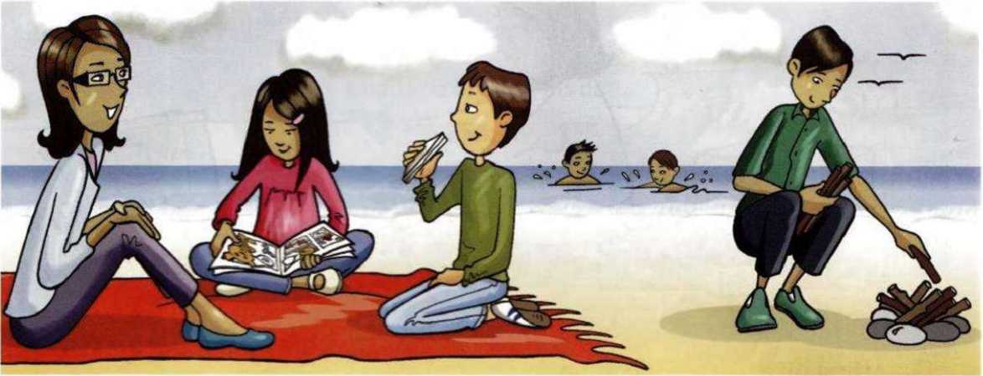

Charlie and Harry

mum

Mary

dad

Peter

1.Mary________________________________________________________

2.Peter________________________________________________________

3. Mum, Mary and Peter __________________________________­­­­­_______

4. Charlie and Harry__________________________________________

**V. Answer the questions about you**

1. Do you like flying a kite?

_______________________________________

2. What do you like doing at the beach? _______________________________________

3. What’s your favorite season ?

_______________________________________

4. Where are you from ?

_______________________________________

5. Are you a student ?

_______________________________________

6. What do you like doing in your free time ?

_______________________________________

7. How many people are there in your family?

_______________________________________

8. How old are you ?

_______________________________________

9. What month is it ?

_______________________________________

10. What time do you get up ?

_______________________________________

11. Do you have breakfast at six thirty ?

_______________________________________

12. Are you listening to music in your free time ? _________________________

 **VI. Look and answer the questions.**

1. Is she from Brazil?



1. Where are they from?



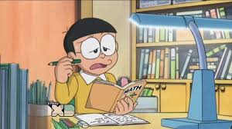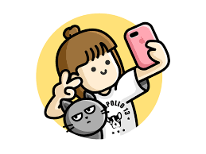

1. Does Nobita like doing homework?
2. What does she like doing?

**VII. Reorder the words to make sentences.**

1. bigger / is / The elephant / than / ant / the / .

* _________________________________________________

1. My / is /favorite / season / summer / .

* _________________________________________________

3. eating / He / a / is / sandwich / .

* _________________________________________________

4. don’t / They / doing / like / gymnastics / .

____________________________________________________

5. are / seasons / Ho Chi Minh / There / two / in / city / .

* _________________________________________________

6. favorite / is / My / season / summer / .

* _________________________________________________

7. I / your / player / Can / use / DVD / ?

* _________________________________________________

8. this / ’m / monkey / I / watching / funny/ .

* _________________________________________________

9. you / a / Are / reading / book / ?

* _________________________________________________

10. doesn’t / He / shower / have / a / night / at / .

* _________________________________________________

11. start / What / time / work / they / do / ?

* _________________________________________________

12. Farmers / every / gets / morning / up / early / .

* _________________________________________________

13. after / Do / brush / they / teeth / their / meal / ?

* _________________________________________________

14. Are / your / you / friends / and / waterskiing / ?

* _________________________________________________

15. In / winter / the / , / We / go / often / outside / and / kites / fly / .

* _________________________________________________

16. is / factory / a / my / worker / uncle /.

* _________________________________________________

17. a / in / car / he / works / factory /.

* _________________________________________________

18. do / mother / your / does / what /?

* _________________________________________________

19. work / she / does / where / ?

* _________________________________________________

20. brother / your / what / do / does / ?

* _________________________________________________

21**.** Do / friends/ your / park / to / go / the / Saturdays / on / ?

* _________________________________________________

22.First, / brushes / She / teeth/ her / and / dressed / gets / then / she / .

* _________________________________________________

23.play / I / friends / my / with / school / after

* _________________________________________________

24. They / work / go / to / car / by

* _________________________________________________

25. my / I / homework / do / after / TV / watching / .

* _________________________________________________

**VIII. Make the questions.**

1. I like playing volleyball.

* ........................................................................................ ?

2. I’m from Viet Nam.

* ........................................................................................ ?

3. My birthday is in June.

* .............................................................................................?

4. I’m eleven.

* ............................................................................................. ?

5. They are from America.

* ............................................................................................. ?

6. Yes, I am. I’m from Korea.

* ............................................................................................. ?

7. His favorite season is Summer.

* ............................................................................................. ?

8. No, it isn’t. The crocodile is not sleeping.

* ............................................................................................. ?

9. Yes, it is my computer.

* ............................................................................................. ?

10. No, you can not turn on the DVD player.

* ............................................................................................. ?

11. No, the monkeys are not climbing.

* ............................................................................................. ?

12. He catches the bus everyday.

* ............................................................................................. ?

13. My favorite animal is rabbit.

* ............................................................................................. ?

14. I live in Binh Duong province.

* ............................................................................................. ?

15. She goes to school at six o’clock.

* ............................................................................................. ?

**IX. Read and choose the answer A, B or C.**

My name is Liam. I’m ten years old. There are four people in my family. My parents, my sister and me. My dad is a doctor. He works in St. Paul Hospital. My mum is a teacher. She teaches English at Kim Lien Primary School. My sister is a student of Thang Long University. I am a pupil at my mum’s school. I love my family.

|  |  |  |
| --- | --- | --- |
| 1. His father is a _________. | |  |
| **A.** teacher | **B.** doctor | **C.** student |
| **2.** He works in __________ Hospital. | |  |
| **A.** Kim Lien | **B.** Thang Long | **C.** St. Paul |
| **3.** His mother teaches English at a ________. | |  |
| **A.** primary school | **B.** secondary school | **C.** university |
| **4.** His sister is a _________ . | |  |
| **A.** teacher | **B.** student | **C.** pupil |
| **5.** Liam studies at his ________. | |  |
| **A.** mother’s school | **B.** father’s school | **C.** parents’ school |

**X. Circle the correct past simple of BE**

1. We ***was / were*** in the kitchen.

2. Alex ***wasn’t / weren’t*** at the cinema.

3. They ***were / was*** hungry.

4. It ***wasn’t / weren’t*** rainy yesterday.

5. I **was / were** at home yesterday.

6. **Was / Were** Amy and Leo at the cinema last night.

7. It **was / were** sunny yesterday.

8. I and Mai **was / were** at the party last week.

XI**. Complete the questions with Do or Does**

1. _______Paul like riding horse?
2. _______you like playing computer games?
3. _______Jack like playing the piano?
4. _______Ann like playing volleyball?
5. _______Amy and Sally like reading?
6. _______they like swimming?
7. _______ Peter and Leo go swimming ?
8. What time ________ he catch the train ?
9. They _________ not have dinner at seven o’clock.
10. Minh ________ not go to school by bus.

**XII. Read and answer the questions**

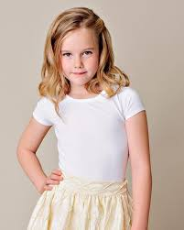Hi, my name’s Julie. I’m from the U.S.A. I like shopping and

playing badminton. I also like cooking. I often help my mother

cook meals. I don’t like fishing because it’s very boring.

1. *What’s her name? _________________________________*
2. *Is she from Korea? ________________________________*
3. *What does she like doing? ______________________________________________*
4. *Does she like fishing? ________________________________*

**XIII. Read and circle.**

|  |  |
| --- | --- |
| 263.  1. I ride ***my/ their*** bike to school. | 29  *4.* ***Her/ his*** dog is lovely. |
| 28    2. We use ***his/ our*** camera to take photos. | 31  5. This is ***your/ their*** key. |
| 30   1. **Their/His** cat is nice. | 27  6. They walk ***his/ their*** dogs everyday. |

1. **Write the sentences (add more words).**
2. penguins / swim / ?

* Are the penguins ___________________________?

1. zebra / run / ?

* __________________________________________

1. girl / take a photo / ?

* __________________________________________

1. lizards / eat / ?

* __________________________________________

1. crocodile / sleep / ?

* __________________________________________

6. you / get dressed / morning / ?

* __________________________________________

7. Ly and Vy / not / catch the bus / school

* __________________________________________

8. she / taking photos / ?

* __________________________________________

9. he / eating sandwich / ?

* __________________________________________

10. There / lots of / hotels / .

* __________________________________________

11. The people / friendly . /

* __________________________________________

12. The boy / not / eating / some ice cream / .

* __________________________________________

13. There / four / people / family / .

* __________________________________________

14. How many / shells / he / have / ?

* __________________________________________

15. Duy / have / collection / ?

* __________________________________________

16. I / not / like / playing the guitar / .

* __________________________________________

17. He / not / like / reading comics / weekend / .

* __________________________________________

18. They / not / from / Brazil / .

* __________________________________________

19. Jaidee / Tai / brothers / . / They / Thailand / .

* __________________________________________

20. It / rains / a lot / rainy season / .

* __________________________________________