Name: _________________ GRADE 5 – VHA

I. Complete the words:

A_ _ tr _ _ _a | s_ _s_ _ _ | p_ _ _ b_ s_ _ _ba_ _ | _ _ r _
II. Write
1. An elephant is _____________ (big) than a monkey.
2. January, _______________ , March, April, May.
3. Fifty, six, seventy, eighty, ninety, ______________________.
4. Peter likes ________________ (swim).
III. Circle the two words that have the same sound.
1. face bike small space 2. rope tube kite cube
3. spoon park snake shark 4. scarf soil oil oyster
IV. Matching.
Answers | A | B
1 - | 1. Does he like playing chess? | a. No, they aren’t. They’re eating.
2 - | 2. Can you open the window, please? | b. I like fishing.
3 - | 3. Where are they from? | c. Yes, you can.
4 - | 4. What do you like doing? | d. No, he doesn’t.
5 - | 5. Are the lizards sleeping? | e. They’re from Brazil.
6 - | 6. Can I use your DVD? | f. Yes, I can.
7 - | 7. Are you sleeping? | g. She’s from Thailand.
8 - | 8. Where’s she from? | h. No, I’m not. I’m reading.

V. Read the text and write T (True) or F (False).
Hello, my name is Nga. I am ten years old. I’m from Ha Noi. There are four seasons here: spring, summer, fall and winter. My family often go to the beach in the summer. Nha Trang is the perfect place for snorkeling. The water is not polluted. The beach is beautiful with white sand. I like snorkeling and my dad likes playing volleyball on the sea. My mom likes taking photos. We love the summer. It’s my favorite season of all.

1. Nga is 9 years old. ________
2. She’s from Ho Chi Minh City. ________
3. The beach in Nha Trang is clean. ________
4. She doesn’t like snorkeling. ________
5. There are four seasons in Ha Noi. ________
6. Her dad likes playing volleyball. ________
7. Her mom likes waterskiing. ________
8. Her favorite season is spring. ________

VI. Write sentences to descride this picture. Using the words in the box.
eat a sandwich jump swim hold his shoes play with a ball

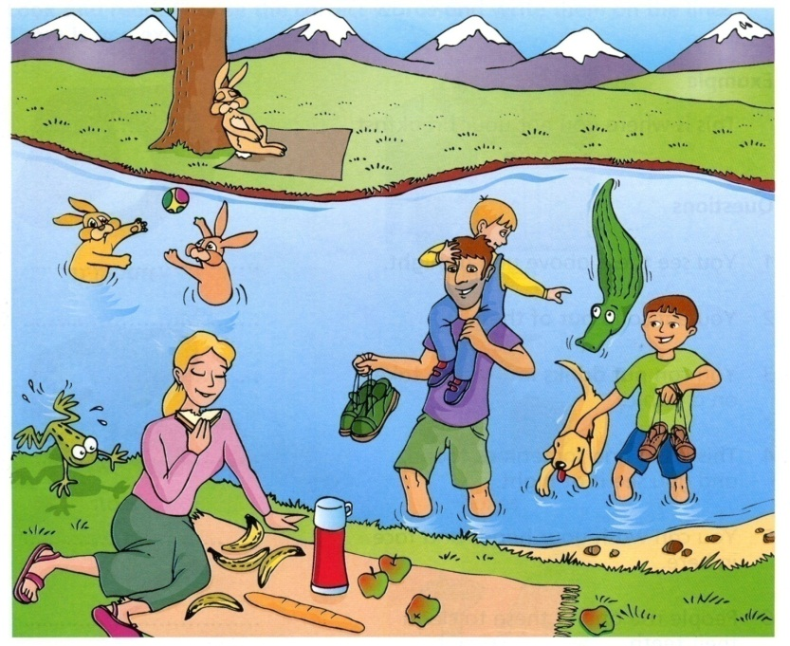
1.Mom____________________________.
2. The rabbits ______________________
3. Dad ____________________________
4. The frog_________________________
5. The crocodile____________________

GOOD LUCK!

