TEST 2 – GRADE 5
Name: __________________________Class: ________
- Odd one out
1. | a. fire fighter | b. shopping | c. cycling | d. fishing
2. | a. spring | b. autumn | c. winter | d. lake
3. | a. drum | b. flute | c. gate | d. violin
4. | a. bus | b. train | c. plane | d. tube
5. | a. face | b. nose | c. mouth | d. time
6. | a. January | b. February | c. June | d. month
- Circle the two words that have same sound
1. | a. space | b. cube | c. bike | d. face
2. | a. stone | b. June | c. rope | d. lake
3. | a. line | b. flute | c. gate | d. white
4. | a. home | b. cube | c. plane | d. tube
5. | a. face | b. nose | c. bone | d. time
6. | a. kite | b. race | c. June | d. nine
- Read and match
1. | Can I use your DVD player? | a. | He has one hundred shells.
2. | How many shells does he have? | b. | She’s from Korea.
3. | Where is Rosa from? | c. | Yes, you can.
4. | What’s your favorite season? | d. | My favorite season is summer.
5. | Is the monkey eating the sandwich? | e. | No, it isn’t.
1 - ________ ; 2 - ________ ; 3 - ________ ; 4 - ________ ; 5 - ________
- Write the verb
1. | I _____________ breakfast. | 2. | I ___________ my homework. | 3. | I _____________ my teeth.
4. | I ___________ to school. | 5. | I _____________ dressed. | 6. | I ___________ outside.

- Circle the correct word. Then write a short answer.
1. | Is he / I fishing? | No, _____________________________.
2. | Are I / they playing chess? | Yes, ____________________________.
3. | Are she / you watching film? | No, _____________________________.
4. | Does he / they live in a big house? | Yes, ____________________________.
5. | Do she / we get up early? | No, _____________________________.
6. | Does she / you like taking photos ? | Yes, ____________________________.
- Write.
1. | He _____________ (get) up at eight o’clock. | 2. | They _____________ (live) in a big house.
3. | She ____________ (have) breakfast with her family. | 4. | He _____________ (have) a shower in the morning.
- Read the story. Choose a word from the box and write.
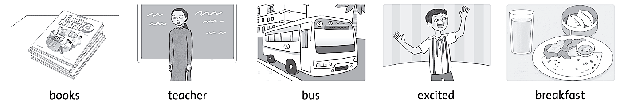
My name’s Vinh. Today is my first day in a new school. I get up early. I don’t want to be late! I pick up my ____________ and go to the kitchen to have my _________________. I leave home with my dad. He catches the __________, and I walk to school. I feel very ________________! When I get to school everyone is friendly. My new _____________ is called Miss Tam and she’s very nice. I like my new school !

