Name: _________________ GRADE 5 – VHA

- Fill in the blank.
- He .................... playing chess.
- How many puppets .................. he have?
- The monkey is ...................... a banana.
- .............. you eating? Yes, I am
II. Read and circle.
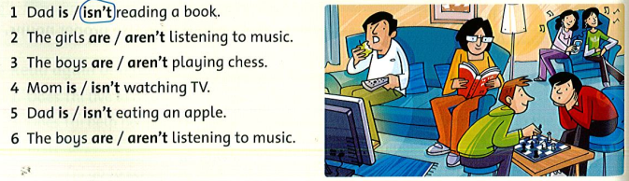
- Read and write T (true) or F (false) .
My name is Linh , and I’m from Viet Nam. I live with my parents and my younger brother. We all get up early every morning. After breakfast, my brother and I walk to shool. We sing the national song every Monday morning. We take a nap at lunchtime, and then we have more lessons. Shool finishes at four o’clock. In the evenings, my mom cook dinner. I go to bed at ten o’clock.
- Linh is from Thailand. _______
- She lives with her grandpa. _______
- She goes to bed at ten o’clock. _______
- School finishes at five o’clock. _______
- Her brother and she walk to school. _______
- They sing the national song every morning. _______
- Write .
.............................. ............................. ..............................
............................... .............................. .............................
- Reorder the words to make sentences.
- are / seasons / Ho Chi Minh / There / two / in / city / .
..............................................................................................................
- favorite / is / My / season / summer / .
..............................................................................................................
- I / your / player / Can / use / DVD / ?
.............................................................................................................
- this / ’m / monkey / I / watching / funny/ .
.............................................................................................................
- you / a / Are / reading / book / ?
............................................................................................................
VI. Make the questions
1. I like playing volleyball.
........................................................................................ ?
2. I’m from Viet Nam.
........................................................................................ ?
3. My birthday is in June.
.............................................................................................?
4. I’m eleven.
............................................................................................. ?

