Name:___________________________ Class: 2A__

1/ Look and write
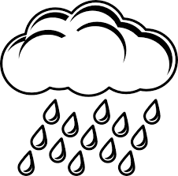

a/ ________ b/ ____________ c/ _____________
2/ Write
- It’s ___________. I’m hot.
- It’s raining. I’m ___________
- It’s___________. I’m cold.
- It’s = _____________
- I’m = ____________

3. Match

● ● noodles

● ● chicken

● ● soup

4. Reorder words to make correct sentences.
a. hungry/ am/ I. ___________________________-
b. It/ is / good. _______________________________
d. some/ Have/ soup. ___________________________
5. Fill in the box with correct words.

Weather | Feelings | Food

