EXERCISE 2
Name: …………………………….. Class: 2A__
- Odd one out:
- Pillow yellow blanket bear
- hot cold that wet
- my sunny raining snowing
- am is are bed
- chicken soup quiet noodles
- Look and write. ( Nhìn tranh và viết):
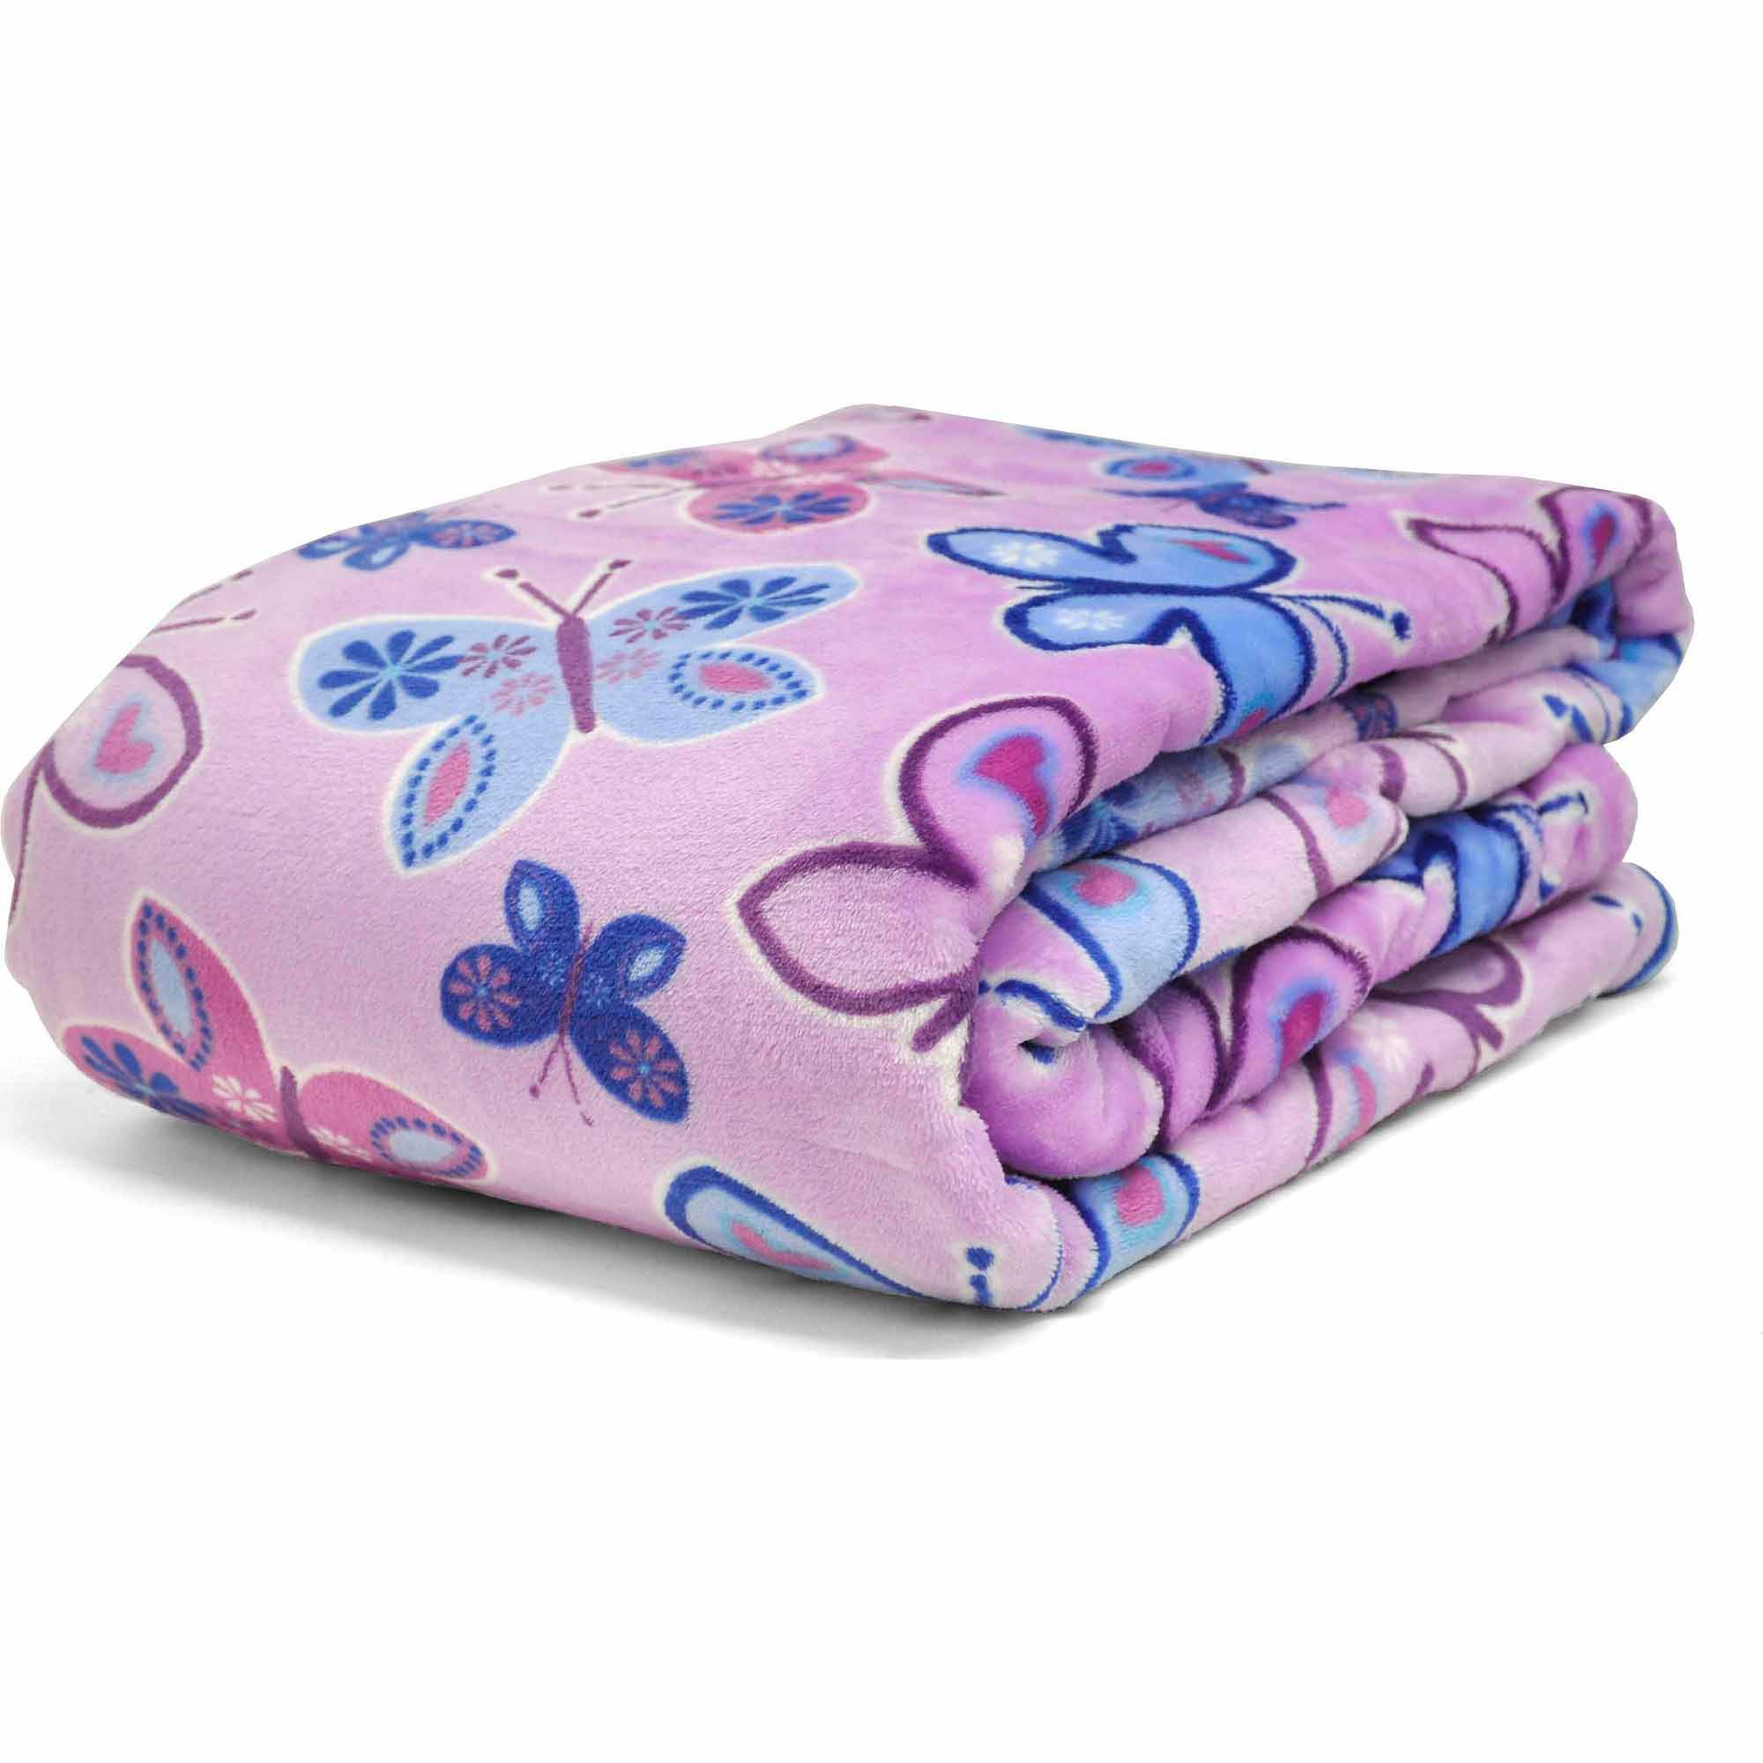  1. …………………. | 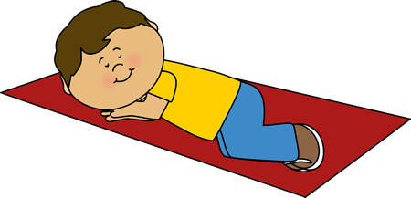  2…………………….. |   3…………………….. | 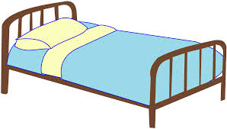  4……………………..
  5…………………….. |   6…………………….. | 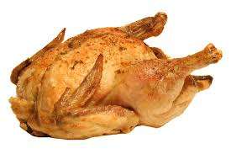  7…………………….. |   8………………..
  9…………………….. |   10…………………… |   11…………………….. | 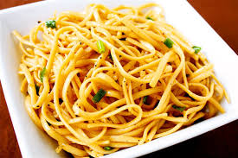  12……………………..
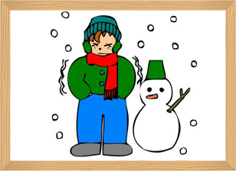  13………………….. |   14…………………… | 15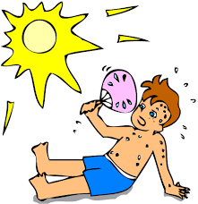…………… | 16.……………

- Unscramble
1. S O N I G N W => _______________ 2. W T E H R A E => _______________
3. B A L K T E N => _______________ 4. L C H N U E M T I => ______________
5. D E S L O N O => _______________ 6. F E A R R M => _______________
7. P E C I L O F O I F E R C __________________ 8. E A B R => ___________

IV. Connect: ( nối câu cho phù hợp)
 | A. It’s raining. I’m wet.
1. How are you? | B. Have some chicken.
2. Hurry up | C. I’m cold.
3. It’s snowing. | D. No. It’s my pillow.
4. I’m hungry. | E. I’m hot.
5. That’s my pillow. | F. I’m fine. Thank you.
6. It’s sunny. | G. Mmm. It’s good.
7. Have some noodles. | H. No. It’s my bear.
8. That’s my bear. | I. It’s my blanket.
 | K. My name’s Nam.

1…….,2…….,3……..,4……,5…….,6…….,7…….,8……..
V. Reorder
1. raining / is / It / . / wet / am / I
=> …………………………………………………………
2. thirsty / am / I / . / want / I / juice / .
=> …………………………………………………………
3. Have / noodles / some / chicken / and
=> …………………………………………………………
4. No. / my / teddy bear / It / is
=> …………………………………………………………
5. this / my / teacher / English / is
=> …………………………………………………………
6. slow / yellow / light / .
=> …………………………………………………………
7. not / is / She / farmer / a
=> …………………………………………………………

