TEST 1

Name: _______________ Class: 2A__
I. Fill in the blank:
chicken soup noodles hungry

1. I’m ___________. | 
2. Have some ___________. | 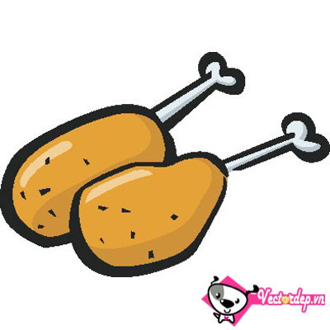
3. Have some ___________. | 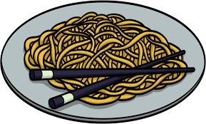
4. Have some ___________. | 

II. Circle:
5. pillow bear blanket soup
6. candy wet cold hot
7. police officer farmer sunny doctor
8. chicken green soup noodles
III. Check ☑ the correct sentence:
 | 9.  It’s raining.  It’s sunny. | 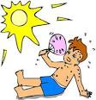 | 10.  I’m hot.  I’m cold.
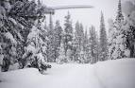 | 11.  It’s raining.  It’s snowing. |  | 12.  I’m cold.  I’m wet.
 | 13.  It’s snowing.  It’s sunny. | 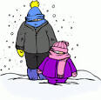 | 14.  I’m wet.  I’m cold.

IV. Circle the correct answer:
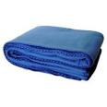 | 15. That’s my______.  A. blanket  B. pillow  C. bear | 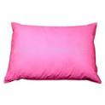 | 16. No! It’s my_______.  A. bear  B. blanket  C. pillow
 | 17. She’s a ________.  A. farmer  B. doctor  C. police officer | 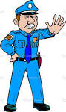 | 18. He’s a _________.  A. police officer  B. farmer  C. doctor
 | 19. I want ________.  A. candy  B. chips  C. ice cream | 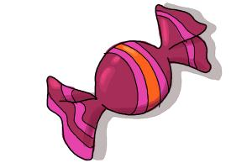 | 20. I want ________.  A. ice cream  B. candy  C. chips

GOOD LUCK!

TEST 2

- WRITE.

1. 2. 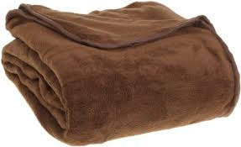 3. 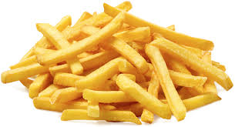
…………………… ……………………….. ……………………….
4 . 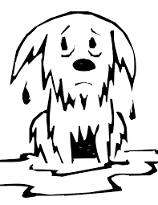 5.  6. 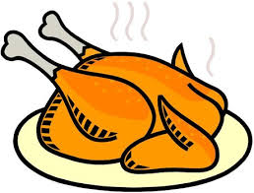
…………………… ……………………………. ……………………………
7. 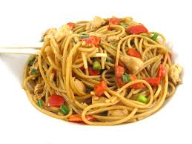 8.  9. 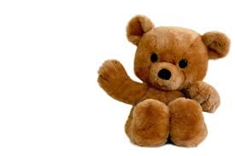…………………… ………………………. …………………

- REORDER.
hungry / ’m / I
  - …………………………………………………………………
chicken / some / have
  - ………………………………………………………………..
Some / noodle / have
  - ………………………………………………………………
Have / soup / some
  - ………………………………………………………………
candy / want / I
  - ………………………………………………………………
is / a / police / She / officer
  - ………………………………………………………………
my / pillow / That / ’s
  - ………………………………………………………………
- MAKE SENTENCES.
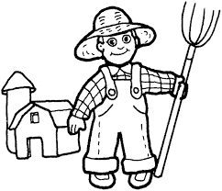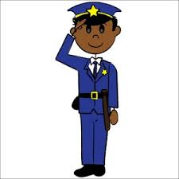

He is a……………… …………………………….. ……………………………
He’s a………………. ……………………………... ……………………………
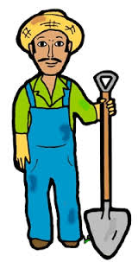
She is a …………….. ………………………….. ……………………………
She’s a ………………. ………………………….. ……………………………
IV. COMPLETE THE DIALOGUE.
Mommy: Hurry _______!.It’s sunny.  Benny: I’m __________ | Benny: I _____ ice cream.  Mommy: No,Benny.Not _____
Sue: I’m _______  Mommy: _______ some soup.  Benny: Mmm.It’s _______ | Benny: Hey! Daddy’s _____  Daddy:: _______ home.  Sue: _____ my daddy.
Sue: _______ my pillow.  Benny: No! _____ my pillow.  Mommy: Shh! Be _____! | Mommy: Red _________ . Stop.  Benny:Green _______. Go.  Sue: She’s a _________ __________
V.CHOOSE THE CORRECT ANSWER A, B ,C OR D:
1. Play with me.
A. Mmm.It’s good B. Shh!Be quiet C. Ok.Let’s run D. She’s a doctor
2.Where’s the towel?
A. No!It’s my bear B. Here it is C. I like rice D. I’m hot
3. It’s snowing.
A. I’m hot B. I don’t like soup. C. I’m wet D. I’m cold
4. I want chips.
A. No, Sue.Not today B. Here it is C. He’s my brother D. I don’t like rice.
VI. Circle the best answer.
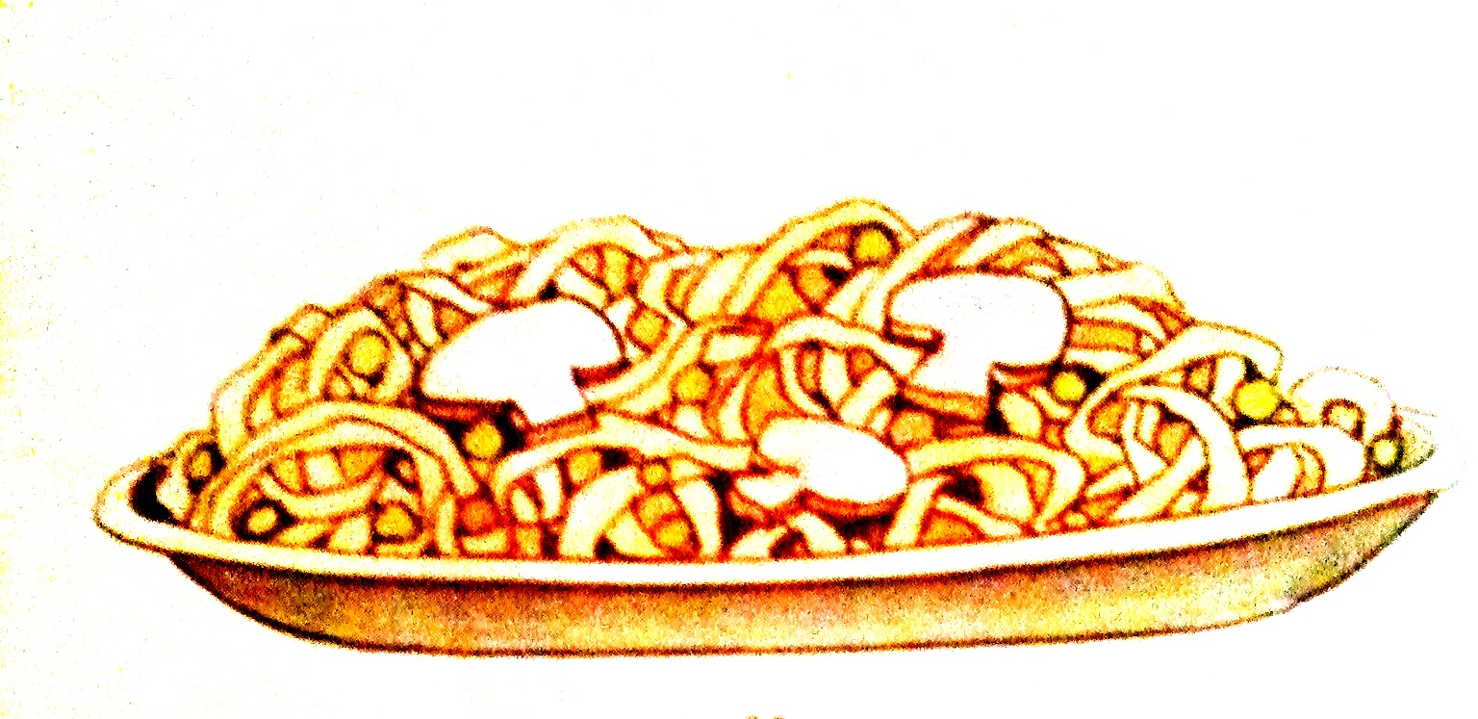  1. I’m hungry.  a. Have some noodles  b.Have some soup. | 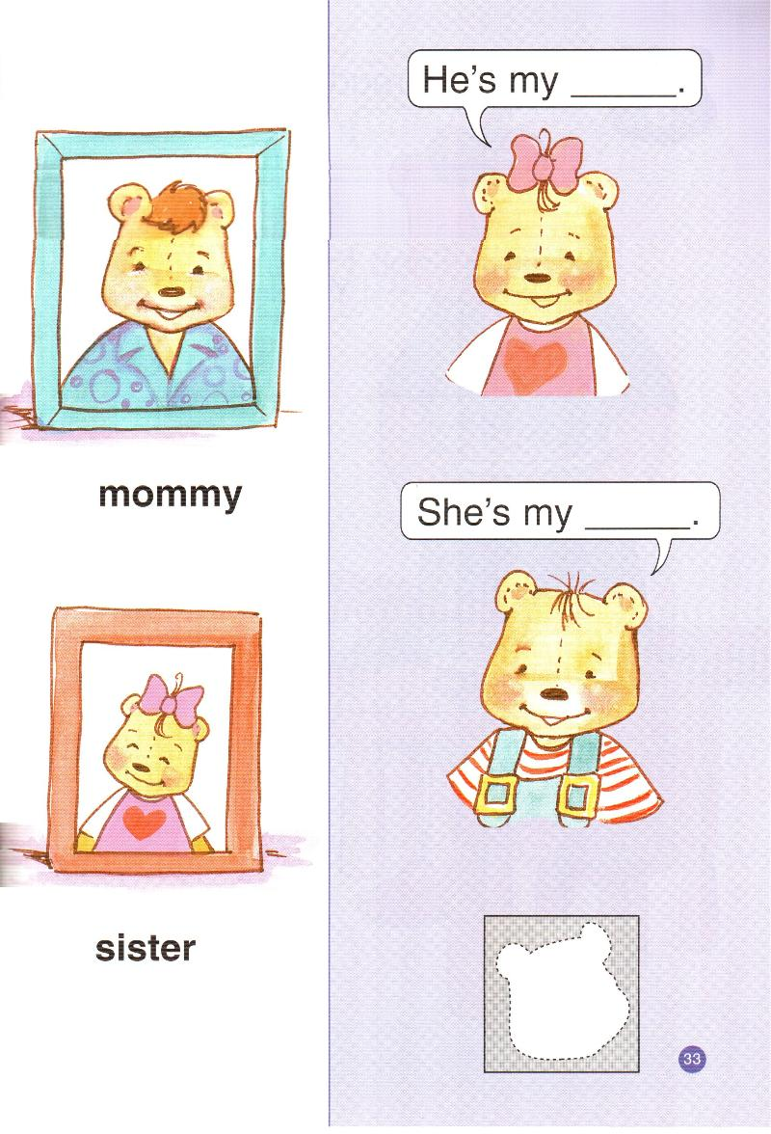  4. Hey! Mommy is home.  a. She’s my mommy.  b.She’s my sister.
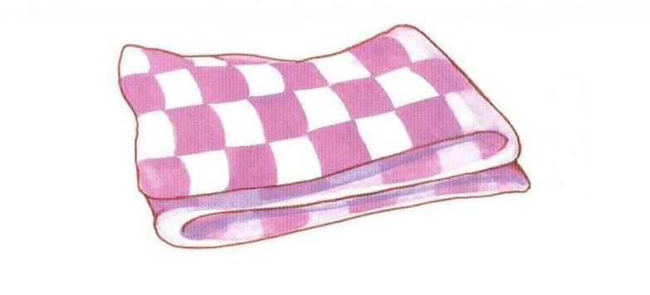  2. a. that’s my pillow.  b. That’s my blanket. | 5. Play with me.  a. Ok.Let’s swing.  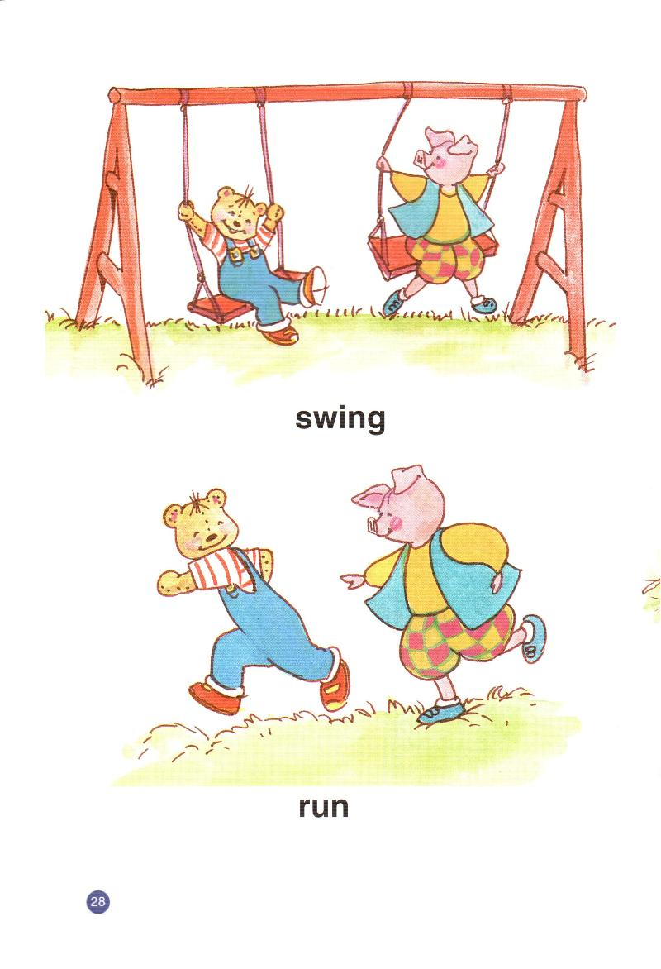  b.OkLet’s run.
3. It’s sunny.  a. I’m hot    b.I’m cold. | 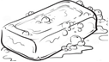  6. Where is the soap?  a. Here it is.  b.Good night.

TEST 3
- ODD ONE OUT:
- Pillow yellow blanket bear
- hot cold that wet
- my sunny raining snowing
- am is are bed
- chicken soup quiet noodles
- LOOK AND WRITE.
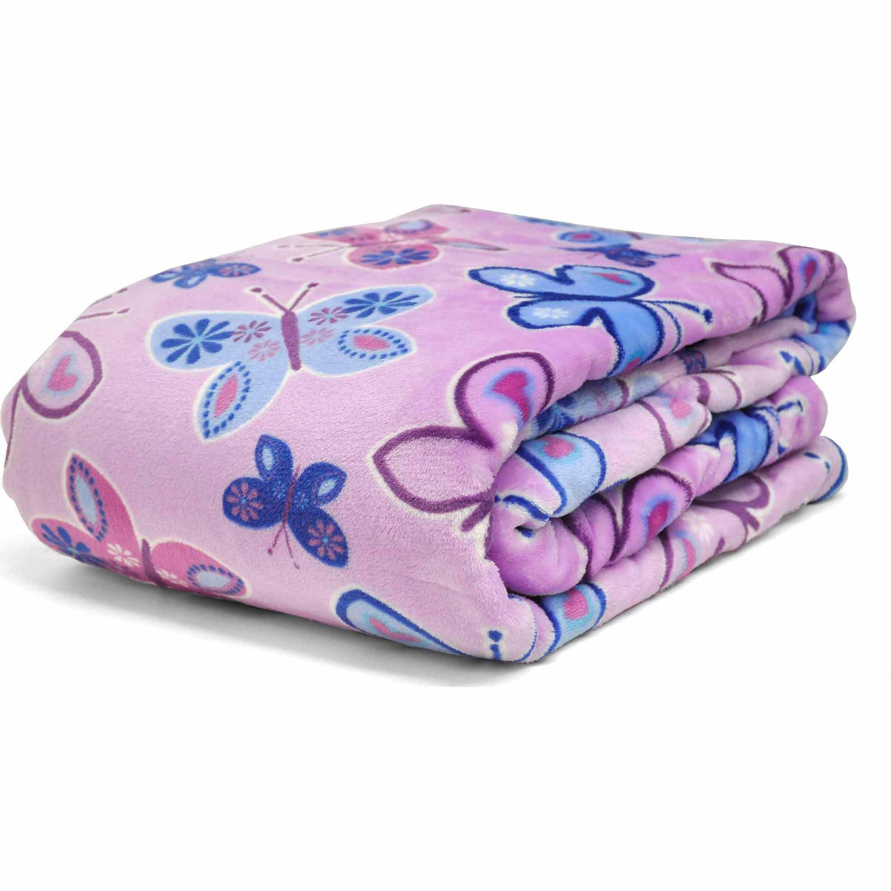  1. …………………. | 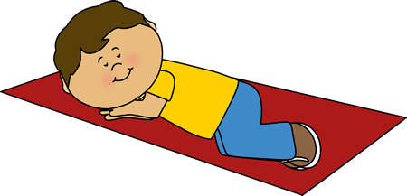  2…………………….. |   3…………………….. | 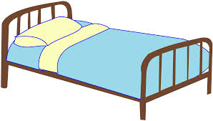  4……………………..
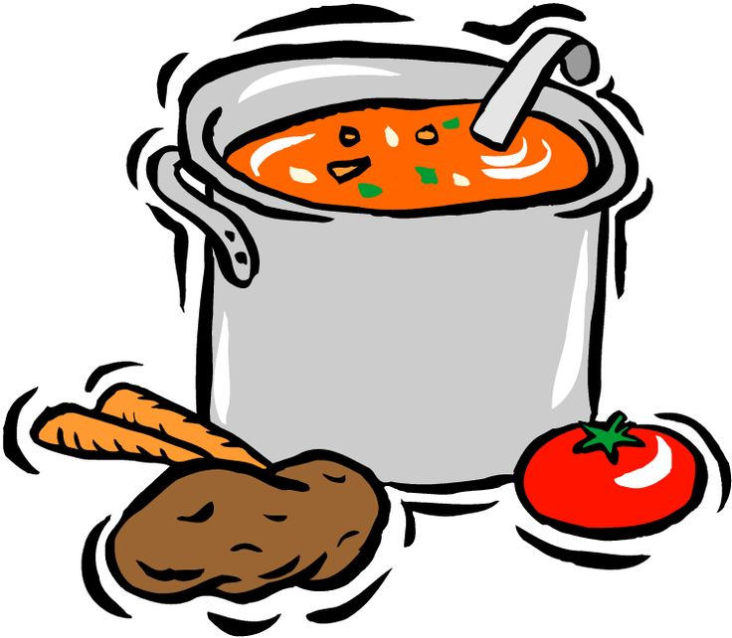  5…………………….. | 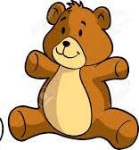  6…………………….. | 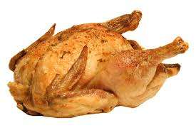  7…………………….. | 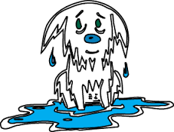  8………………..
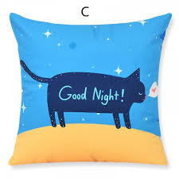  9…………………….. | 10…………………… |   11…………………….. | 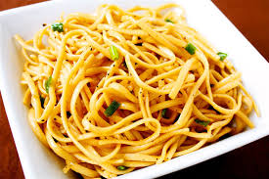  12……………………..
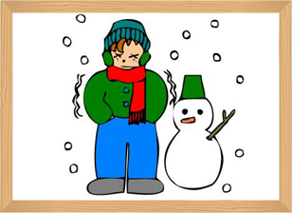  13………………….. | 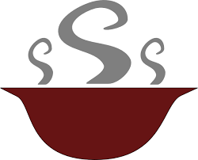  14…………………… | 15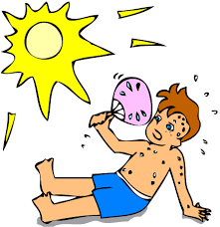…………… | 16.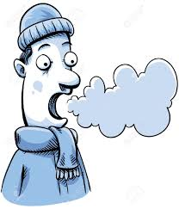……………

III. UNSCRAMBLE
1. S O N I G N W => _______________ 2. W T E H R A E => _______________
3. B A L K T E N => _______________ 4. L C H N U E M T I => _____________
5. D E S L O N O => _______________ 6. F E A R R M => _______________
7. P E C I L O F O I F E R C _________________ 8. E A B R => ___________

IV. CONNECT
 | A. It’s raining. I’m wet.
1. How are you? | B. Have some chicken.
2. Hurry up | C. I’m cold.
3. It’s snowing. | D. No. It’s my pillow.
4. I’m hungry. | E. I’m hot.
5. That’s my pillow. | F. I’m fine. Thank you.
6. It’s sunny. | G. Mmm. It’s good.
7. Have some noodles. | H. No. It’s my bear.
8. That’s my bear. | I. It’s my blanket.
 | K. My name’s Nam.

1…….,2…….,3……..,4……,5…….,6…….,7…….,8……..
V. REORDER
1. raining / is / It / . / wet / am / I
=> …………………………………………………………
2. thirsty / am / I / . / want / I / juice /
=> …………………………………………………………
3. Have / noodles / some / chicken / and
=> …………………………………………………………
4. No. / my / teddy bear / It / is
=> …………………………………………………………
5. this / my / teacher / English / is
=> …………………………………………………………
6. slow / yellow / light /
=> …………………………………………………………
7. not / is / She / farmer / a
=> …………………………………………………………
8. Hey / home / Daddy / is
=> …………………………………………………………
9. She / my / not / grandma /
=> …………………………………………………………
10. brother / my / He / is
=> …………………………………………………………

TEST 4
- CORRECT THE MISTAKES (Sửa lỗi sai)
- Daddy home. =>…………………………………………….
- Mommy home. =>…………………………………………….
- Im home. =>…………………………………………….
- Iam home. =>…………………………………………….
- Hes my father. =>…………………………………………….
- Sheis my mother. =>…………………………………………….
- She’s my broter. =>…………………………………………….
- He’s my siter. =>…………………………………………….
- I likes candy. =>…………………………………………….
- I dont’ like chicken. =>…………………………………………….
- ODD ONE OUT
- yellow green red pillow
- slide swim doctor swing
- teacher farmer student banana
- bread meat chicken fish
- milk candy chip cake
- hot wet raining cold
- daddy family brother sister
- orange book yogurt bread
- home father mother grandmother
- swim am is are
III. CHOOSE AND WRITE

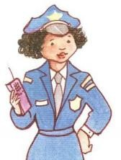  ....................... | 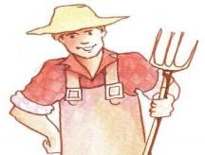  ............................ |   .......................... | 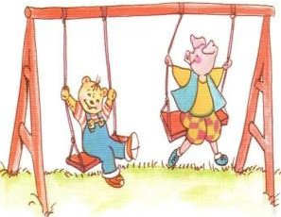  .............................
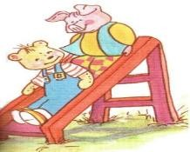  ....................... | 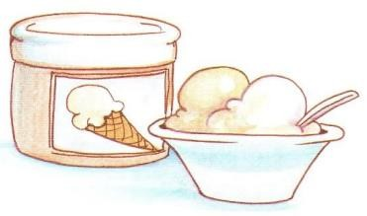  ....................... | 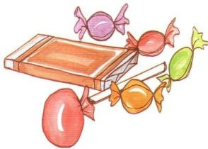  ....................... | 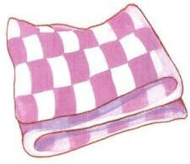  .......................

IV. LOOK, READ AND WRITE.
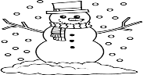 | It’s . | A. wet B. cold C. hot
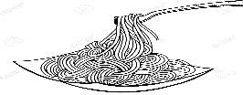 | some noodles. | A. Have B. It’s C. Let’s
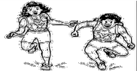 | run. | A. Have B. It’s C. Let’s
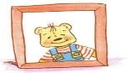 | He’s my . | A. daddy B. sister C. brother
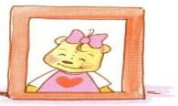 | She’s my . | A. mommy B. sister C. brother
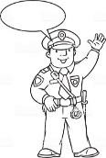 | a police officer. | A. It’s B. He’s C. She’s
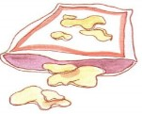 | chips.  - No. Not today. | A. It’s B. I want C. Let’s
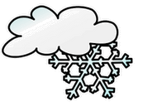 | It’s . | A. snowing B. sunny C. raining
V. MATCH (Nối)

1. It’s sunny. |  | a. I’m home.
2. Play with me. |  | b. No, not today.
3. I’m hungry. |  | c. Ok. Let’s play.
4. I want candy. |  | d. I’m hot.
 |  | e. Have some chicken.
1. ............. | 2. .............. | 3. ................ | 4. .................
- CORRECT THE MISTAKES ( Sửa lại lỗi sai)
  - Hungry up! It’s snowing. – I’m wet.
➔ …………………………………………………………………
  - She’s my brother.
➔ ………………………………………………………………….
  - Phay with me. Ok, Let slide.
➔ …………………………………………………………………
  - He’s a famer. ➔ …………………………………………………………
TEST 5


I. LOOK AND WRITE( I want…./ I don’t want….)
a. _______________________ c. _____________________

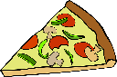
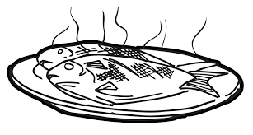
b. ________________________ d. ________________________
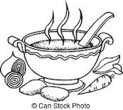

e. ________________________ f. _______________________

g. _______________________ h. _______________________


i. _______________________ j. _______________________

II. LOOK AND WRITE
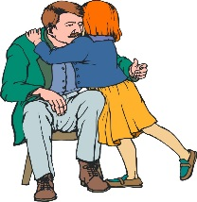

1.
2.

He’s my
She’s

3.
4..
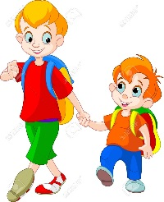
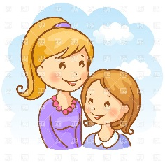

She’s

He.

III. CIRCLE THE ODD ONE OUT
1. family father mother brother
2. swing slide chips run
3. noodles chicken hungry soup
4. want one three five
5. I He She yellow
IV. MATCH
A | B
1. He’s my daddy. | a. I am home.
2. I’m home. | b. No. It’s my blanket.
3. That’s my blanket. | c. Ok. Let’s swing.
4. Play with me. | d. Fine. Thank you.
5. How are you ? | e. He’s my father.

V. COMPLETE THE WORDS
1.  | p……………………..
2.  | g…………..
3.  | f…………..
4. 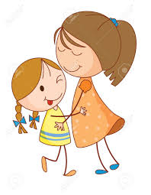 | s………………..
5. 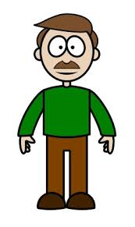 | f…………….
6. | m…………….
7.  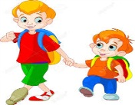  b……………. |   8. g…………….

VI/ WRITING
- Hu.......... up !. ................ raining.
................ wet.
- It’s .....................
................ cold.
- I’m .....................
Have ..................... noodles.
Mmm. It’s .................

