Name: __________________ REVIEW GRADE 5 – (30/3 – 3/4/2020)
REVIEW UNIT 1
- Look at the FLAGS and write the names of the countries
1. | 2. | 3. | 4.
5. | 6. | 7. Viet Nam | 8.

- Ask and answer, using WHERE?
- Where are you from?
I am from Viet Nam.
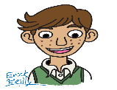
- Where ………………………………………………
……………………………………………………….

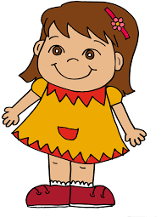
- Where ………………………………………………
………………………………………………………

- Where ……………………………………………..
……………………………………………………..

- Complete the correct word in the blank
comb | spoon | play | crayon | drink

- I color the picture with a……………. .
- I have some soup with a ……………… .
- I …………… milk every day.
- I ………….. my hair every morning.
- I …………… with my friends after school.
- Complete the passage
There are two seasons in Ho Chi Minh City. There is a dry season and a rainy season. It (1)…………… rain in the dry season. We go (2)…..………. picnics because we don’t (3)……..………. wet. It rains a lot in the (4)….…………. season. We take an (5)………………with us when we go out.
REVIEW UNIT 2
- Complete ONE VERB in the blank
- ………………….book
- ………………….gymnastics
- …………………chess
- …………………photos
- …………………basketball
- …………………family
- …………………TV
- …………………pictures
- …………………the guitar
- …………………family
- Circle the two words that have the same sound
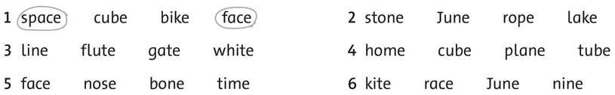
- Underline the full form. Write the short form.
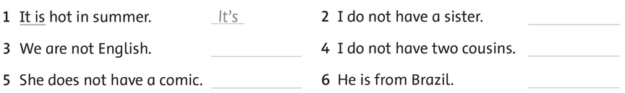
- Write
- I (like) (play) like playing badminton.
- He (like) (play) …………………………………..the piano.
- She (like) (swim) ………………………………… .
- My dad ( like) (read) ……………………………….books.
- My sister ( like) ( take) ………………………………..photos.
- They ( like) ( fish)…………………………………… .

THE END.

REVIEW UNIT 3
- Look and write
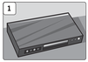 | 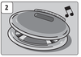 | 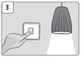 | 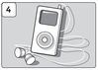
DVD player
 | 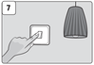 | 8 | 9 | 10

- Unscramble
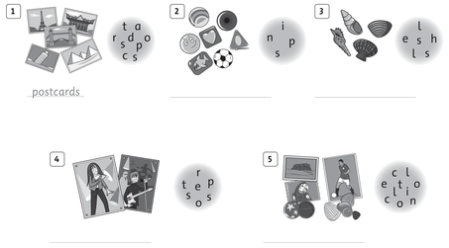
- Look and write
- 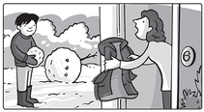  Can you put on your coat, please?  Yes, I can. | - 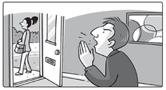  Can you ____________________ , please?  Yes, I can.
- 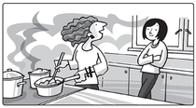  Can you ____________________ , please?  Yes, I can. | - 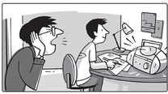  Can you ____________________ , please?  Yes, I can.
- 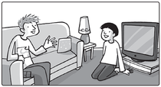  Can you ____________________ , please?  Yes, I can. | - 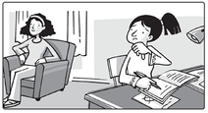  Can you _______________________ , please?  Yes, I can.

REVIEW UNIT 4
- Unscramble
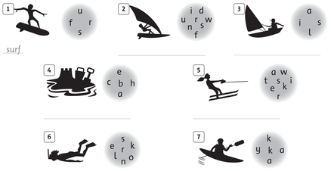

- Look and write the sentences, using the present continuous tense
1.She’s eating a sandwich. | 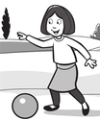  2. ___________________________
3.  ____________________________ | 4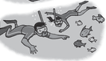  ___________________________
5.  ___________________________ | 6.  ___________________________

- Write the verb then answer the question
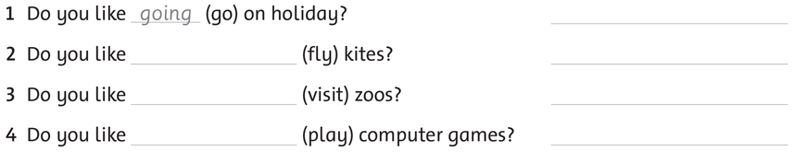

REVIEW UNIT 5
- Write

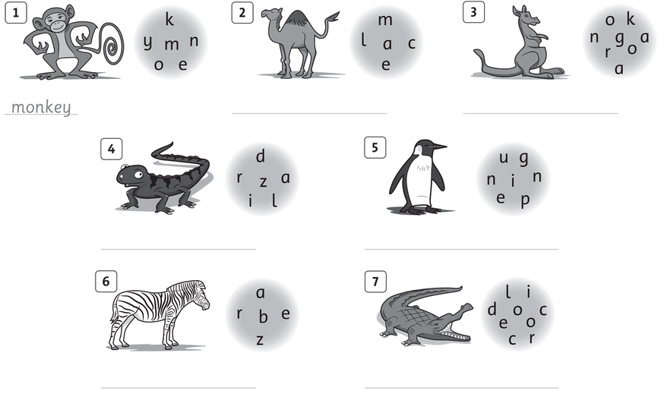

- Write the question
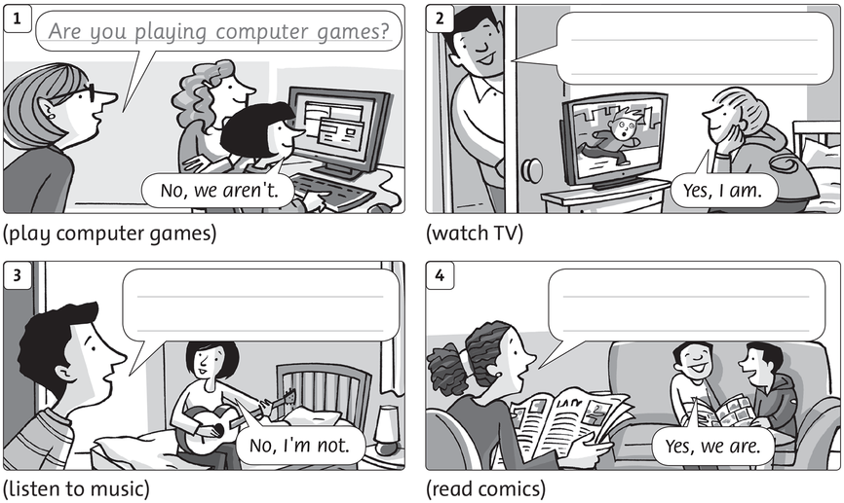
- Guess the animals. Write about them
- big and tall/ brown and red/ big feet and big ears/ Australia/ run and jump
____________________________________________________________________________________________________________________________________________________________________________________________________.
- big and long/ in water/ swim and walk/ dangerous/ eat fish
__________________________________________________________________
__________________________________________________________________________________________________________________________________.

REVIEW UNIT 6
- Look and write
.
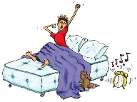
.
II. Read and circle the corrct words.
- She gets/ get up early. | - We catch/catches the bus. | - Xuan have/has breakfast with her family.
- Leo brushes/brush his teeth every morning. | - I have /has shower every day. | - Do/does you go to school everyday ?
- Lan have /has breakfast every morning. | - Do/Does they catch the bus every morning? | - They don’t go /goes to school everyday.
- Amy don’t/doesn’t catch the bus. - What time do/doesToby go to school? - Do/Does they brush their teeth at night ? | - Anna and Leo don’t/doesn’t catch the bus. - What time do/doesToby go to school? - Do/Does they brush their teeth at night ? | - Anna don’t/doesn’t watch TV at night. - What time do/doesToby go to school? - Do/Does they brush their teeth at night ?
- She don’t/doesn’t walk to school. - My sister get/gets up at six o’clock. - Do/Does she have a shower at night ? | - They don’t/doesn’t walk to school. - My sister get/gets up at six o’clock. - Do/Does she have a shower at night ? | - He don’t/doesn’t walk to school. - My sister get/gets up at six o’clock. - Do/Does she have a shower at night ?

