Vinh Hoa A primary school
Name………………………...Class 4A.…
Mark  .......... | Teacher’s comment.  …………………………………………………………………………………  …………………………………………………………………………………
SỞ ANH NGỮ VICTORY Date : Monday, November 21st, 2016
ĐT: (064) 6257 457 Name :
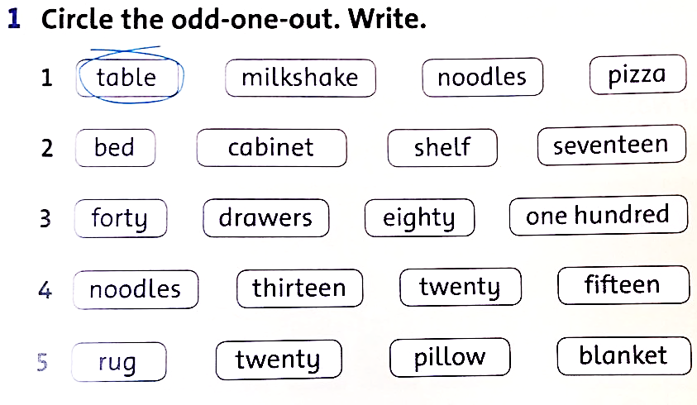
C

table_____
_____________
_____________
_____________
__________
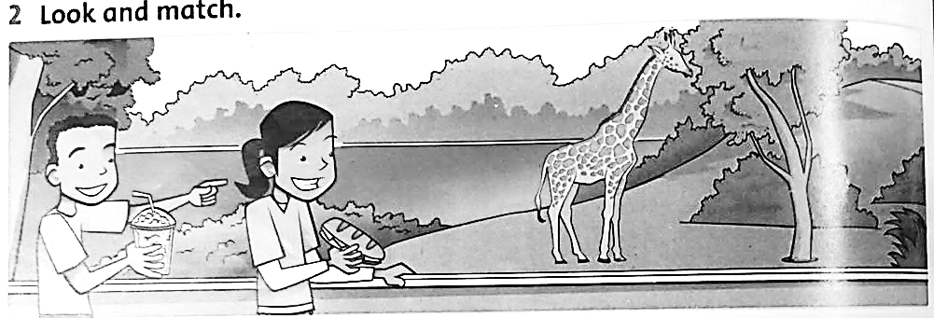

gr__
________
________
________

1. | There are two beds. T_
2. | There’s a kite under a bed. ____
3. | There are books on the cabinet. ____
4. | There are pants on the rug. ____
5. | There are pillows on the beds. ____
