Vinh Hoa A primary school
Name:……………………….
Class 2A……
Marks | Remarks of teacher
I. Write the words.(viết từ vựng)

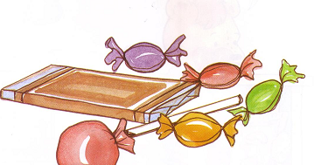  1 | 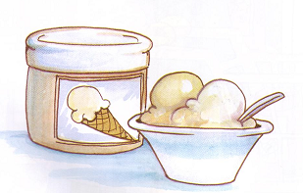  4
2. | 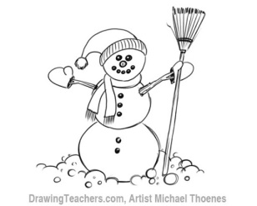  5
3.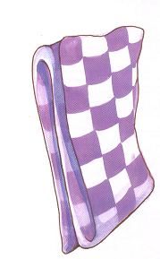 | 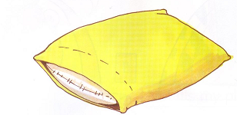  6

II.Match(nối)

- That’s my |  | Candy
- Have some |  | Ice cream
- She’s a |  | Farmer

III.Fill the blank.

- 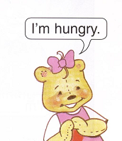 | - 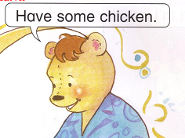
IV. Answer the question.( trả lời câu hỏi)

- What’s your name ? ………………………………….
- How old are you?............................................................
- Who is she ? d. How’s the weather?
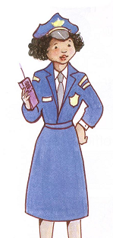…………………… ………………………….
- What do you want? e. Who is Sue? How is she? .………………. …………………………
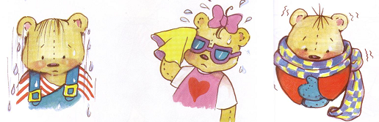
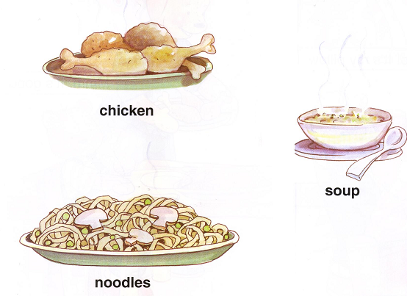

V/ Read the dialogue and complete (chọn từ thích hợp trong khung hoàn thành đoạn hội thoại)

Soup, today, raining, mommy snowing

Mommy: Hurry up Benny! It’s ………………..
Benny: I’m wet
Mommy: Have some soup!
Benny: No, ………... I want candy
Mommy: No, Benny. Not ……... Have some ……….!
Benny: Yes, Mommy.

VI.Odd one out: (chọn từ khác loại)

1 | - Chicken | - Soup | - Cold
2 | - Noodles | - Hot | - Snowing
3 | - Sunny | - Wet | - Soup
4 | - Noodles | - Hungry | - Chicken
VII. Look and write (nhìn và viết)

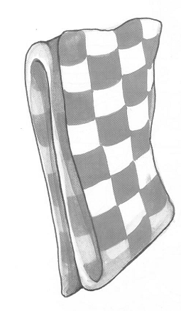 | 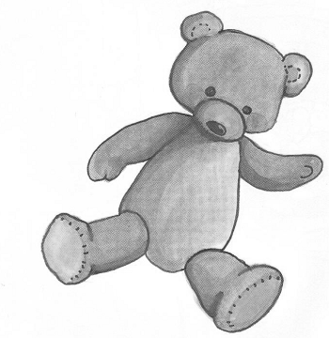 | 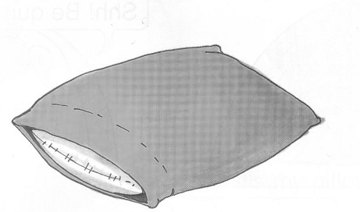
Blan.... | Be.... r | Pill.... w

VIII. Fix (sửa lỗi sai)
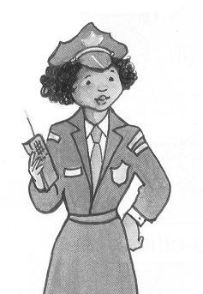 | 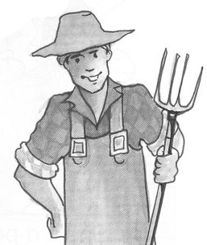
He’s a police officer | She’s a farmer
.................................. | ..............................

