REVIEW 2
I. Write (viết chữ)
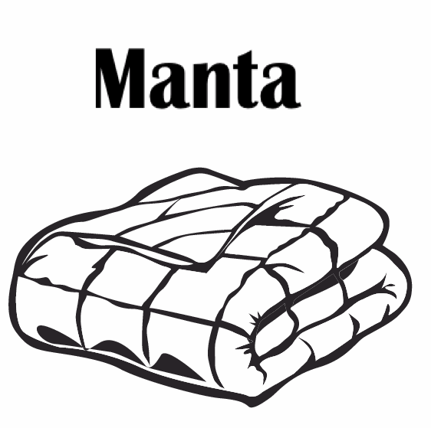 | It’s my blanket .  It’s my blanket .  It’s my blanket . | It’s my blanket .  It’s my blanket .  It’s my blanket . | _______________________  _______________________  _______________________
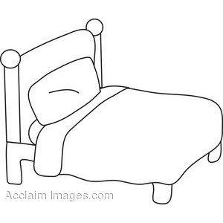 | It’s my bed .  It’s my bed .  It’s my bed . | It’s my bed .  It’s my bed .  It’s my bed . | _______________________  _______________________  _______________________
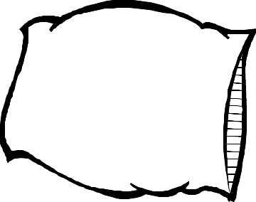 | It’s my pillow .  It’s my pillow .  It’s my pillow . | It’s my pillow .  It’s my pillow .  It’s my pillow . | _______________________  _______________________  _______________________
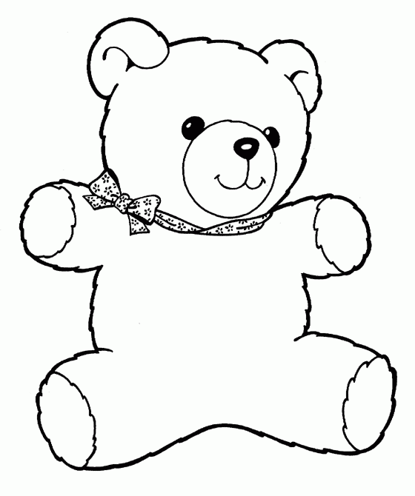 | It’s my bear .  It’s my bear .  It’s my bear . | It’s my bear .  It’s my bear .  It’s my bear . | _______________________  _______________________  _______________________
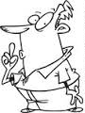 | Be quiet !  Be quiet !  Be quiet ! | Be quiet !  Be quiet !  Be quiet ! | _______________________  _______________________  _______________________

II. Look and write the words (nhìn và viết lại)
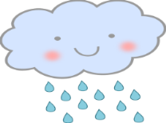 |  | 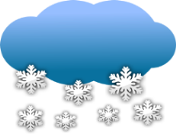 |  | 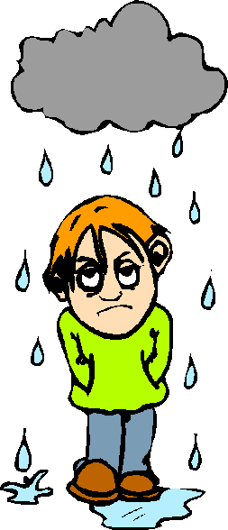
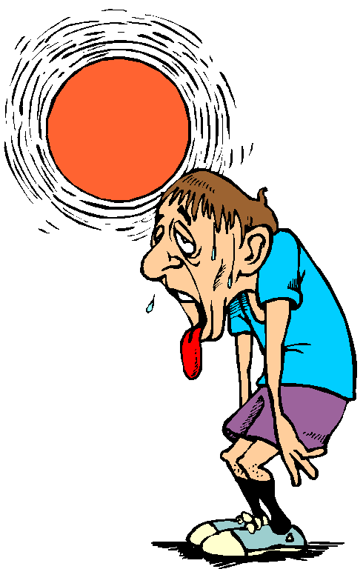 |  | 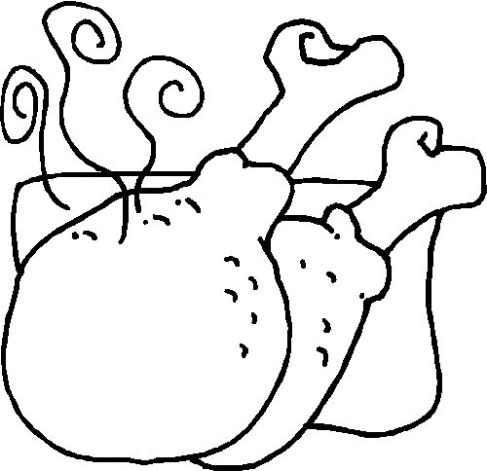 |  | 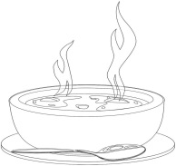
 |  |  |  | 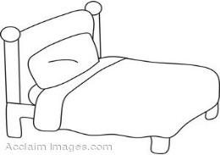

III. choose the best word: (chọn từ đúng)
Pillow be quiet! Bear blanket bed

1. ------------------ | 2. ------------------ | 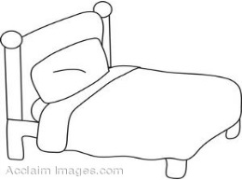  3. ------------------ | 4. ------------------ | 5. ------------------

IV. Choose the best answers: (Chọn đáp án đúng)
1. It’s my _____  a. blanket  b. bed  c. Be quiet! | 2. I’m ________  a. hot.  b. wet.  c. sunny. | 3. Have some _____  a. hungry  b. soup  c. chicken
4. Be _____  a. quiet!  b. cold  c. blanket | 5. It’s _________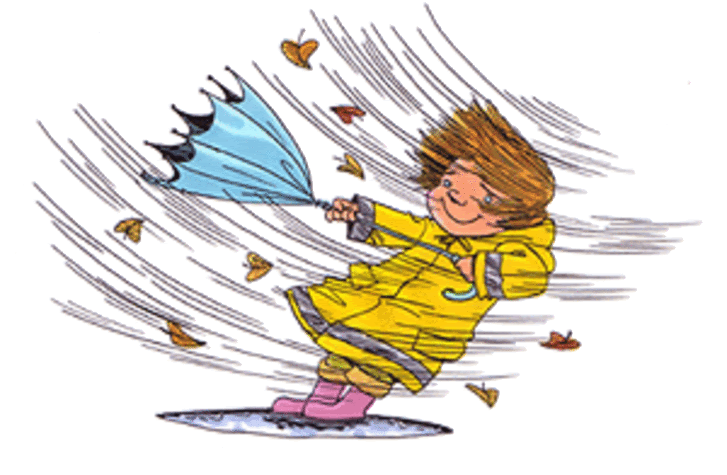  a. cold.  b. windy.  c. hungry. | 6. It’s my _____  a. noodles  b. bear  c. pillow
7. _____ cloudy.  a. I’m  b. It’s  c. cloudy | 8. Have some_____  a. noodles  b. cold  c. chicken | 9. I’m _______  a. raining.  b. snowing.  c. wet.
10. I’m_______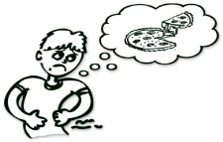  a. cold  b. hungry  c. wet | 11. It’s _________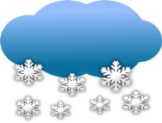  a. chicken.  b. cloudy.  c. snowing. | 12. It’s ____ bed.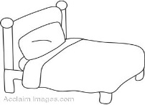  a. I’m  b. bear  c. my
13. _____ cold.  a. I’m  b. It’s  c. Be quiet ! | 14. It’s my _____  a. bed  b. bear  c. pillow | 15. It’s _________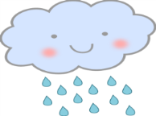  a. sunny.  b. wet.  c. raining.

