ĐỀ ÔN TẬP TỪ 30/3 _ 03/4/2020
VINH HOA A PRIMARY SCHOOL.
NAME: _____________________________.
CLASS: 3A__
REVIEW FOR GRADE 3
1.Fill in the correct circle.
1.A. He’s a doctor. ⃝ 2. A.This is my mom. ⃝
B. He”s a doctor. ⃝ B. This is my moom. ⃝
C.He a doctor. ⃝ C. This iis my mom. ⃝
3.A. My nam’s Biily. ⃝ 4.A.The bike in the tree. ⃝
B. My name’s Billy. ⃝ B. The bike is the tree. ⃝
C.My name Billy. ⃝ C.The bike is under the tree. ⃝
2. Write the sentences with a capital letter and the start of the name:
1.This is harry __________________________
2.these are my legs __________________________
3.this is my granpa __________________________
4.hai and hoa are students ___________________________
5.This is my friend, billy ___________________________
6.she is a police officer ___________________________
3.Write:
1.fa__mer. 2. r__bbit.
3. oran__e. 4. um__rella.
5. seesa___. 6. fris__ee.
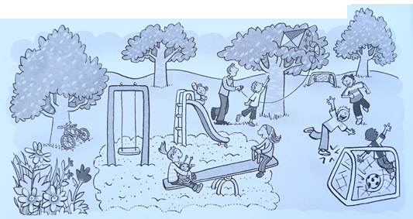
4. Look at the picture. Read and write.
1. A toy is in the goal. What is it? It’s a ______________.
2. A toy is on the slide. What is it? It’s a ______________.
3. A toy is under the tree. What is it? It’s a ______________.
4. A toy is on the seesaw. What is it? It’s a ______________.
5. A toy is in the tree. What is it? It’s a ______________.
5. Read and write T (true) or F (false):
1. There are seven people in the park. _______
2. The ball is in the goal. _______
3. There is one tree. _______
4. The boys and girls are playing. _______
5. There are eight flowers. _______

6.Cirle the words. Write sentence.
1.Closeyourbook. _______________________. 2.Thisismysister.______________________.
3.Whatisyourname? _____________________. 4.Howoldareyou?_____________________.
5.Openthewindow.______________________. 6.Thesearemyfingers.__________________.
7.Thisismyyellowpen. ____________________. 8.Thenoseisgreen.____________________.
9.Howmanyboys? _______________________. 10.Heisateacher.______________________.
7.Color the toys words blue and the family words green.
grandma
car
father
Yo - yo
kite
grandpa
bike
ball
sister
mother
doll
brother

8.Find the words:
t | r | a | i | n | f
h | a | n | d | o | I
b | l | u | e | s | n
f | a | c | e | e | g
o | r | a | n | g | e
e | r | a | s | e | r
1.______________.
2.______________.
3.______________.
4.______________.
5.______________.
6.______________.
7.______________.
8.______________.
9.Read the text and write T (True) or F (False). There is one example.
My name’s Mai. I’m seven. This is my family. This is my dad. He’s a pilot. This is my mom. She’s a teacher. This is my grandpa. He’s a doctor. This is me and my brother. We are a happy family.
1. | Mai is eight years old. | F
 |  | .........................
2. | Her dad is a pilot. | .........................
3. | Her mon is a doctor | .........................
4. | Her grandpa is a teacher | .........................
5. | There are five people in Mai’s family | .........................

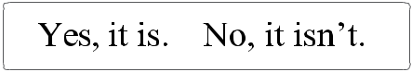
10. Look and write.
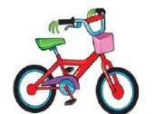
☺ 1. | Is this your |  |  |  | bike |  | ? |  |  |  | Yes, it is.
2. Is this your |  |  |  |  |  | ? |  |  |  | _____________
3. Is this your |  |  |  |  |  |  |  | ? |  | _____________
☺ 4. | Is this your |  |  |  |  | ? |  |  |  | _____________
☺ 5. Is this your |  |  |  |  |  |  |  |  |  | ? _____________
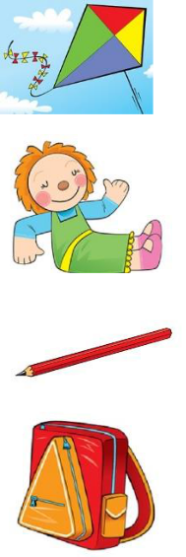
11.Look at the picture and the example (1). Now read the passage.

Then write ONE word into each gap for each picture.

This is the park . There are Bao, Long, Linh and Nga at the park. They love toys.
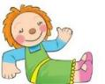
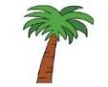

doll | is under a (2) ……………… |  | Long’s car is
Nga’s (1)……………….
in the (3) ……………… | . Bao is playing with a blue (4) ……………..
Linh is flying a (5) ……………….. |  | . They often go to the park at the weekend.
12.Reoder.
1.your/ name/ What/is? ……………………………………
2. old/ are/ you/ How? …………………………………….
3.this/ is/ What? …………………………………….
4. a/ ball/ It/ is …………………………………….
5. nose/ my/ This/ is ……………………………………
6. are/ leg/ These/ my ……………………………………..
7. many/ doors/ How? ……………………………………..
8.purple/ the/ Color/ bag ………………………………………
9. It/ an/ is/ eraser ………………………………………
10. eyes/ The/ blue/ are ………………………………………
11.tiger/ a/ is/ It ………………………………………
12.the/ Cut/ four/ out/ legs ………………………………………
13. lion/ The/ has/ jelly/ some ………………………………………
14. My/ toy/ a/ is favorite/ bike ……………………………………….
15. is/ my This/ doll ……………………………………….

.

