Name: __________________ REVIEW GRADE 5 – (6/4 – 10/4/2020)

REVIEW UNIT 5
- Write

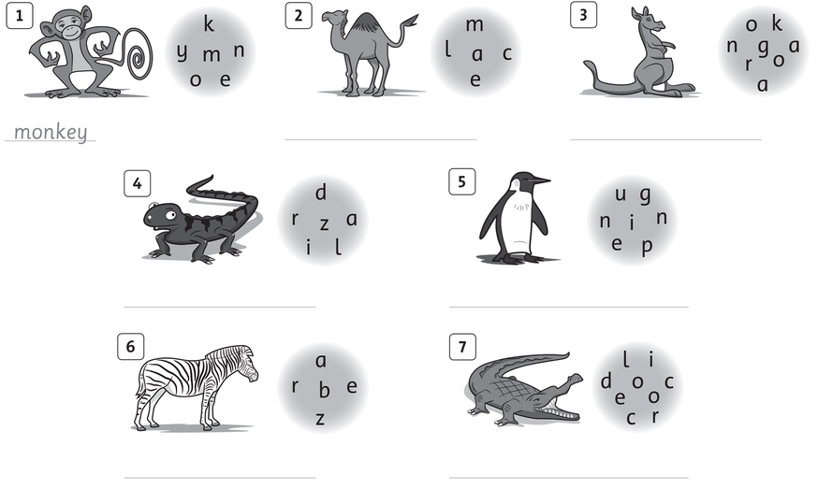

- Write the question
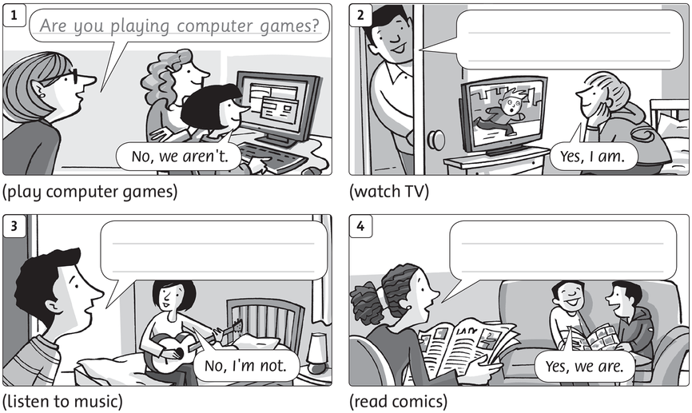

REVIEW UNIT 6
- Look and write
.
.
II. Read and circle the corrct words.
- She gets/ get up early. | - We catch/catches the bus. | - Xuan doesn’t have / don’t have breakfast with her family.
- Leo brushes/brush his teeth every morning. | - I have /has a shower every day. | - Do/does you go to school every day?
- Lan have /has breakfast every morning. | - Do/Does they catch the bus every morning? | - They don’t go /goes to school every day.
III. Fill in the blanks.
- He .................... playing chess.
- How many puppets .................. he have?
- The monkey is ...................... a banana.
- .............. you eating? Yes, I am
- …………the monkeys climbing ? No, they are not.
IV. Write.
.............................. ............................. ..............................
............................... .............................. .............................
IV. Read and circle.
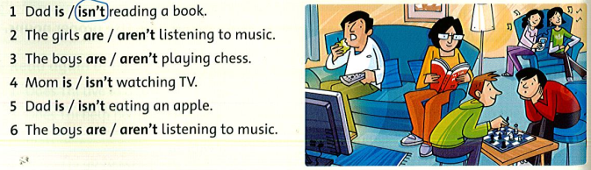
- Read and write T (true) or F (false).
My name is Linh, and I’m from Viet Nam. I live with my parents and my younger brother. We all get up early every morning. After breakfast, my brother and I walk to school. We sing the national song every Monday morning. We take a nap at lunchtime, and then we have more lessons. School finishes at four o’clock. In the evenings, my mom cooks dinner. I go to bed at ten o’clock.
- Linh is from Thailand. _______
- She lives with her grandpa. _______
- She goes to bed at ten o’clock. _______
- Her School finishes at five o’clock. _______
- Her brother and she walk to school. _______
- They sing the national song every morning. _______
VIII. Make the questions
1. I like playing volleyball.
........................................................................................ ?
2. I’m from Viet Nam.
........................................................................................ ?
3. His birthday is in June.
.............................................................................................?
4. I’m eleven.
............................................................................................. ?

