Name: __________________ REVIEW GRADE 5 – (6/4 – 10/4/2020)

REVIEW UNIT 3
- Look and write
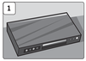 |  | 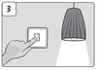
DVD player
 | 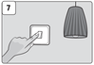 | 8 | 9 | 10

- Unscramble
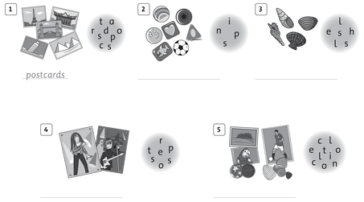
- Look and write
- 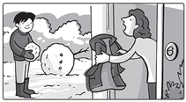  Can you put on your coat, please?  Yes, I can. | - 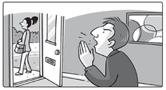  Can you ____________________ , please?  Yes, I can.
- 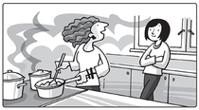  Can you ____________________ , please?  Yes, I can. | - 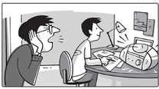  Can you ____________________ , please?  Yes, I can.
- 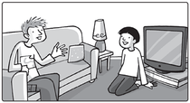  Can you ____________________ , please?  Yes, I can. | - 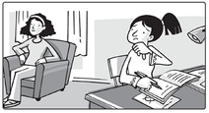  Can you ____________________________________ , please?  Yes, I can.

REVIEW UNIT 4
- Unscramble
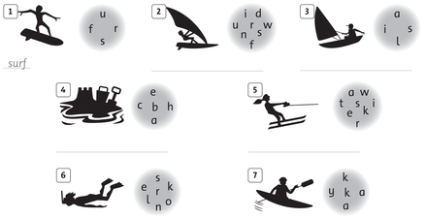

- Look and write the sentences, using the present continuous tense
1.She’s eating a sandwich. | 2. ___________________________
3.  ____________________________ | 4  ___________________________
5.  ___________________________ | 6.  ___________________________

- Complete the sentences.
- Do you like …………………………………………. on holiday ?
- He does not like ……………………………………….. soccer.
- He likes …………………………………………… comics.
- My mom likes ……………………………………meals.
- They do not like ………………………………….photos.
- How many shells …………………… he have ?
- …………..Linh have a puppet collection ?
- I …………….pins and stickers.
- How many dolls ……………you have ?
- There ……………….. twenty postcards.
- The boy is ………………eating ice cream.
- They are ……………………sunglasses.
- We are ……………………at the beach.
- She is ………………..with a ball.
- What do you like ……………….at the beach ?

THE END

