Name:…………………………………… TEST 6
Class:……………… Time: 35 minutes

Mark | Teacher’s comment
 | ………………………………………………….............................................

I.WRITING
1. The alphabet
a. ……… | e. ……… | i. ………
b. ……… | f. ……… | j. ………
c. ……… | g. ……… | k. ………
d. ……… | h. ……… | l. ………
2. Number

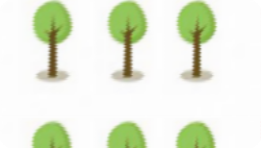 | 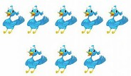 | 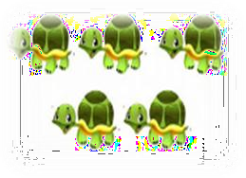 | 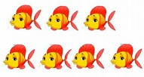
………………………… | ………………………… | ………………………… | …………………………

3. Color
a. Màu vàng ………………………… e. Màu xanh lá …………………………
b. Màu xám ………………………… f. Màu cam …………………………
c. Màu nâu ………………………… g. Màu đen …………………………
d. Màu tím ………………………… h.Màu trắng …………………………
4.put the words in the correct order to make correct sentence.
1. on / There/ the/cabinet/ books / are ………………………………………..
2.Jenny/ toy boxes/ two/ has ………………………………………..
3.computer/ This/ new/the/ is ………………………………………..
4.is/ the/ in / What/ living room/? ……………………………………….
5. the/ boy/ What/ does/ have/? ……………………………………….
6. with/ I / draw / my /pencil. ……………………………………….
7. classroom/ Where/ Lan’s/ is /? ………………………………………..
8. you/ Do/have / milkshake/ ?/ a ………………………………………..

II. MATCH
1. Shapes
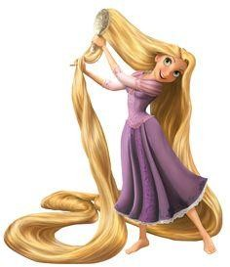
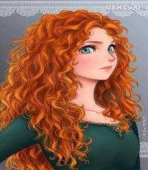

Short Long Straight Cur

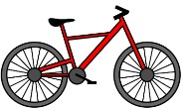
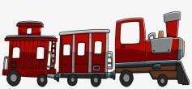2. Things

Bike car ball train
III. MULTIPLE CHOICE
  - How many trains there?
    - Teddy bear b. are c. is
  - How many are there?
    - Car b. two cars c. cars
  - There …… one doll.
    - Are b. is c. am
  - There three trains.
    - Is b. am c. are
  - There is one …………..
    - Bike b. bikes c. five bikes
  - There are eight ……………..
    - Ball b. one ball c. balls
  - She curly hair.
    - Have b. is c. has
  - Billy four years old.
    - Is b. am c. are
  - This is friend.
    - I b. me c. my
  - ………name’s Huy.
    - Her b. I c. His

