\TEST OF ENGLISH FOR THE SECOND GRADERS
School year : 2019 - 2020
Time alloted: 40 minutes
School : Vinh Hoa A primary  Class 2A______ | Student’s name: __________________________ | Scores:

I. Choose the correct answer.
1.It’s raining 2. Have some ____ 3. She’s a ______ 4.This is my ______
A. I’m wet A. hungry A. farmer A. pen
B. I’m hot B. car. B. candy B. noodles
C. I’m cold. C. soup C. farmre C. am

II.Read and complete
Mommy: Hurry up (1)_____! It’s raining.
Benny:I(2) _____ wet
Mommy: Have (3)_______ soup!
Benny: No, mommy. I (4)_______chips.
Mommy: No, Benny. Not (5)______. I have soup!
Benny: Yes, Mommy. It’(6)_______!

III. Circle the odd one out
1. bear bed blanket noodles
2. candy cool cold hot
3. teacher farmer snowing doctor
4. chips blue soup ice-cream
5. number one five six
IV. Circle the correct answer
 | 1. That’s my______.  A. blanket  B. bear  C. bed |  | 2. No! It’s my_______.  A. bear  B. blanket  C. beur
 | 3. ______ a doctor.  A. He’s  B. She’s  C. My |  | 4. He’s a _________.  A. farmer  B. student  C. teacher
 | 5. I want ________.  A. candy  B. chips  C. ice cream | 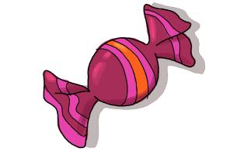 | 6. I want ________.  A. ice cream  B. candy  C. chips

V. Look and write
1. 2. 2. 3. 4.

________________ ____________ ____________ ____________

VI.Reoder the words to make the sentence
1.fish./ some/ Have/ Mmm/ good!/ It’s
________________________________
2.up!/ It’s / Hurry/ raining.
________________________________
3.Sue/ Not/ No,/ today.
________________________________
4. I/ a / student/ am
_______________________________
5. light!/ Yellow/ slow!/ go
______________________________

