School: Vinh Hoa A Primary school  Full name:  Class: 4A |  | ENGLISH EXAM  School year: 2019 – 2020 – GRADE 4  Duration: 35 minutes
Marks | Teacher’s Evaluation

I. Read and tick in the box.
Ex: What does Jane do at 6 am?  She gets up at 6am. | 2.What does Jane do when she gets up?  She takes a bath and then she goes to school.
1. What does Jane do at 6:30?  She has breakfast in the morning. | 3. How does Jane get to school?  She doesn’t go to school by bus. She walks to school.

II. Match the question and answer:

- Does Harry get up early?  - Do Harry and Molly catch the bus to school?  - Do Harry and Molly have breakfast?  - Does Molly walk to school?  - Does Harry have a shower? | - Yes, they do.  - Yes, she does.  - No, he doesn’t  - No, they don’t  - Yes, he does. | 1……….  2……….  3……….  4……….  5 ………

III/ Read a text and write the correct answers. You can use 1,2,3 or 4 words:
My name’s Vinh. Today is my first day in a new school. I get up early. I don’t want to be late! I take my (1)………. and go to the kitchen to have my(2)…………………I leave home with my dad. He catches the bus, and I walk to school. I feel (3)………………! When I get to school everyone is friendly. My new(4)…..……...…. is called Miss Thi and she’s very nice. I like new new school already!
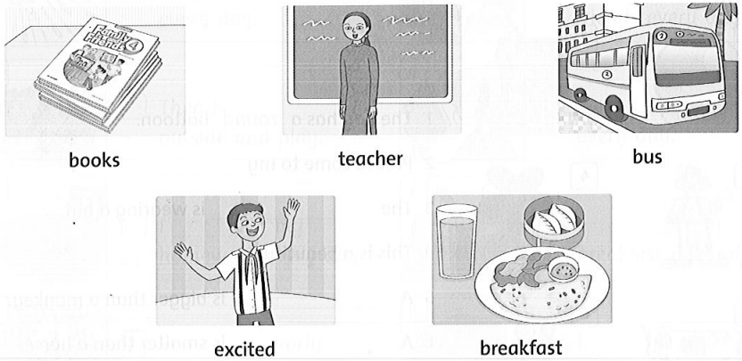
IV. Read and circle
1. My name’s Dony. I like / likes / am balloons.
2. She do not likes / does not like / like sweets or nuts.
3. Herry have / is / has breakfast at seven o’clock.
4. Nam and Lan work / works / are work in a hospital.
5. He do not has / does not has / has / lunch at ten o’clock.
V. Answer the question.

1. When do you get up? ……………………………………………………….
2. What do you do in the morning? ……………………………………………………….
3. Where ‘s your school? ……………………………………………………….
4. When do you have dinner? ……………………………………………………….
5. What do you like? ………………………………………………………
VI.Circle the odd-one-out. Write.

1. table / milkshake / noodles / pizza . __table___
2. bed / cabinet / shelf / seventeen. ___________
3. forty / drawers / eighty / one hundred. ________
4. noodles / thirteen / twenty / fifteen. __________
5. rug / twenty / pillow / blanket. ______________
VII.Read and circle the false word and write the correct word.
Hi, my name's An. This is my school. This is the classroom. We come here everyday. We have board and thirty tables and chairs.We come here at break time. We can play badminton and talk to my friends. Look at the room. We have paint and paper here and we can do art. There are lots of computer here. We can learn with the computer. We can study English and Math. It's fun.
1. We have board and three tables and chairs. _______________
2.The students can study English and Music. _______________
3. The children come to the school every Monday and Friday. _______________
4. We can talk badminton at break time. _______________
5. The students can play in the artroom. _______________

